The Official Publication of ALOA—An International Association of Security Professionals

SPECIALTY

LOCKS

Authorized

Personnel Only!

nstalling an X-08 on i Top Secret Sovernment Door

ly Eric Costley, CRL

**February 2004**

**wwuv.aloa.org**

Breck H. Camp Cml PO Box 47070 Atlanta GA 30362-0070

Plus

New Luggage Padlocks, Cabinet Locks  
(Olympus and Keedex), Jake’s Johnny Latch,  
All About Hondas, New Padlocks from  
Master, Safe Servicing (Part 2), and the  
history of the No-Key Padlock!

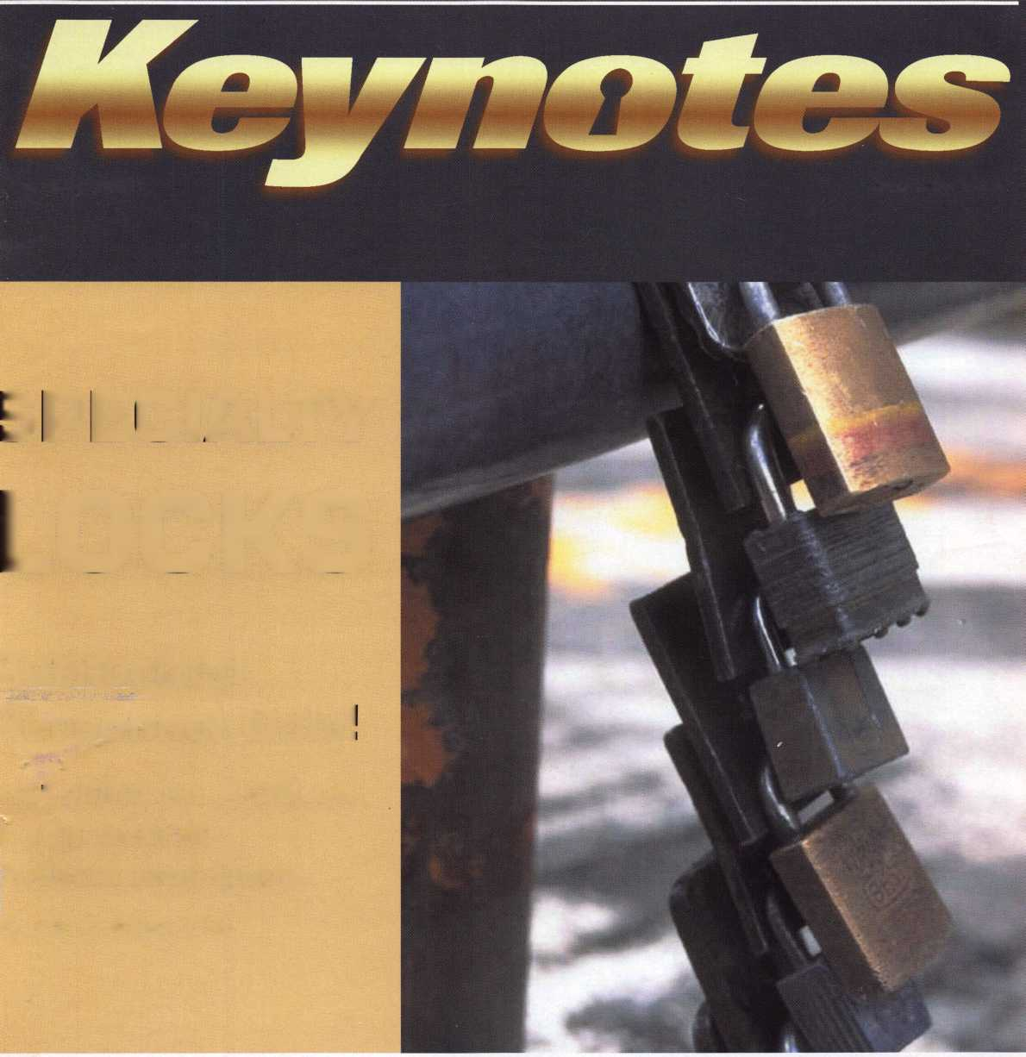

**introducing CODE-SEEKER.**

**NOT JUST A TOOL. A MONEY-MAKING MACHINE.**

**GET A  
CODE-SEEKER  
FOR ONLY**

**USD**

**PLUS TAX**

**PROFIT FOR YOU!**

**QUICKER payback**

SEEKER

**CODE-SEEKER**

* **FREE UPGRADES in 2004!**
* **An UPGRADE SUBSCRIPTION of only $499 per year  
  in 2005 and 2006!**

**•OFFSET THAT UPGRADE FEE.**

**Get $1 credit toward the subscription fee for every  
STRATTEC transponder key purchased through an**

**authorized STRATTEC distributor! (Up to $499; no cash back value.)**

* **24-7 customer service and support!**
* **A name you can trust in automotive  
  lock technology!**

**call 414**-**247-3333** **to order.**

**ASK FOR CODE-SEEKER SALES.**

**Part #708884**

**strattecXL**

**ONE SOURCE. MANY SOLUTIONS.**

**©2004 STRATTEC SECURITY CORPORATION All rights reserved**

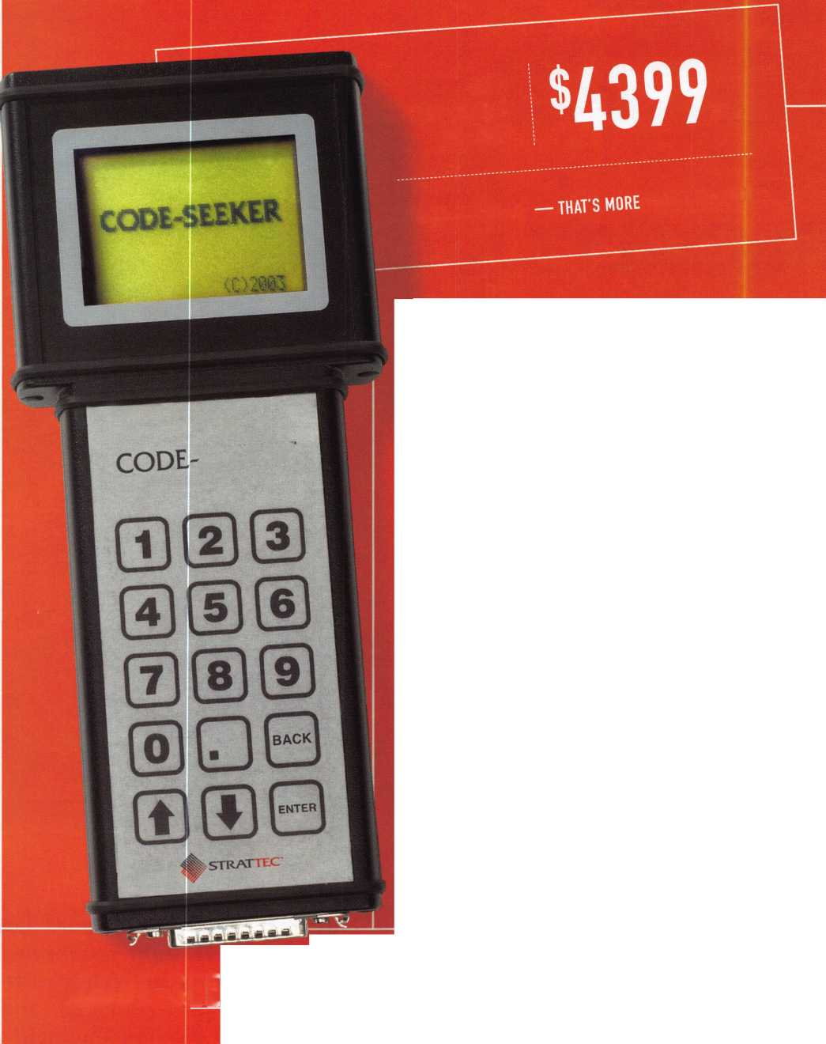

**PROFIT FROM TECHNOLOGY.**

**FORD TRANSPONDER KEYS FROM STRATTEC**

**YOUR OEM KEY SOURCE**

**Ford Crown Victoria 1998-2002 Ford Excursion 2000+**

**Ford Expedition 1998-2001 Ford Explorer 1998-2000 Ford F-Series Pick-up 1999+ Ford Mustang 1996+**

**Ford Ranger Pick Up 1999-2000 Ford Taurus LX/SHO 1996-1999**

**Ford Windstar 1999-2000 Lincoln Blackwood 2002 Lincoln Continental 1998-2002 Lincoln Navigator 1997-2002 Lincoln Town Car 1998-2002 Mazda Pick-up 1999-2000 Mercury Sable 1996-1999 Mercury Grand Marquis 1998-2002 Mercury Mountaineer 1998-2000**

**Ford Crown Victoria 2003+ Ford Expedition 2002+**

**Ford Explorer 2001+**

**Ford Ranger Pick-up 2001+**

**Ford Taurus 2000+ Ford Thunderbird 2003 Ford Windstar 2001+ Mazda Pick-up 2001+**

**Ford Thunderbird 2001-2002 Lincoln LS1999-2002 Mazda Tribute 2001+**

**Ford Escape 2000 Ford Focus 2000+**

STRATTEC

**FOR MORE INFORMATION, CONTACT YOUR DISTRIBUTOR.**

DEMAND IT

Need information in a hurryP  
Use AlOA’s Fax On Demand service.

Just call 310-575-5074 and receive:

1. ALOA Index of Documents
2. Becoming a Locksmith (1 pg)
3. Locksmith Career Summary (3pg)
4. Locksmith School List (2pg)
5. ACE Gass Schedule (8pg)
6. Certification lnformation(3pg)
7. PRP Category List (1 pg)
8. ALOA Membership Application!2pg)
9. ALOA List of Benefits (lpg)
10. Scholarship Application Form (lpg)
11. ALOA Video Library Order Form (lpg)
12. ALOA Membership Items Order Form (1 pg)
13. Safe & Vault Technicians Association Member

Application/Subscription Form (2pg)

1. ALOA Chapter Roster (3pg)
2. Legislative Action Network (2pg)
3. Legislative Action Network Newsletters (lpg)
4. Various State Laws (lOpg)
5. Industry Position Pager (lpg)
6. Current Legislative Action Network Newsletters (lpg)
7. Board of Directors Nomination Form (2pg)
8. ALOA Convention Registration
9. ALOA Board Expense Reimbursement &

Request Form

ALOA continues to provide you with this  
and other great benefits and services!

310-515-5014

V. Vritfart

**<&\** SAFE CORPORATION

uoJ

■>1^ Viking Stainless

Fire & Burglary Protection  
State of the Art Composite Fill

Strong • Functional • Attractive

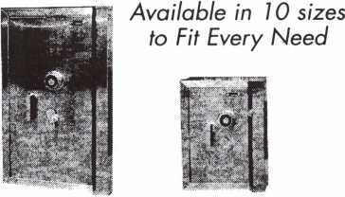

See us at [www.a-bsafecorp.com](http://www.a-bsafecorp.com)

1*-*800*-*253-1267

Fax 856-863-1208

CALL FOR YOUR CATALOG TODAY

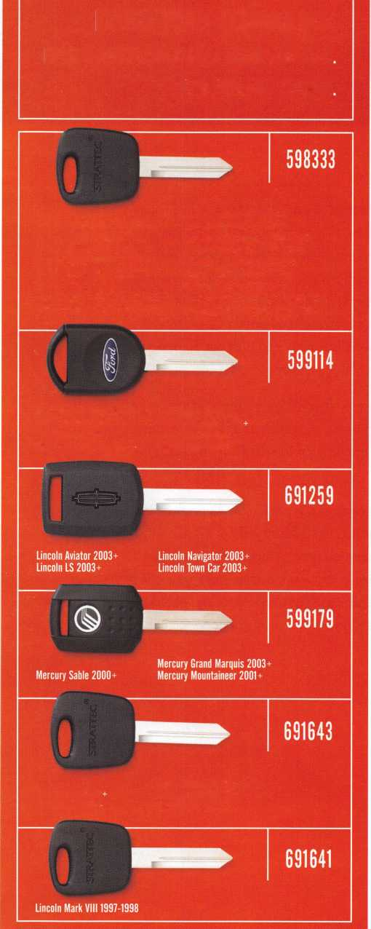

presidential

viewpoint

Dear Members,

The upcoming year holds a great deal of excitement for me. Even-num-  
bered years are when several of the European locksmith associations  
hold their major conventions, and I have made plans to attend three  
such conventions. I'll be attending the Associated Locksmiths of Ireland  
convention in February, the Master Locksmith Association of Great  
Britain in April, and the European Locksmith Federation Convention in  
Berlin, in May. I am looking forward to interacting with our European  
partners and studying the history of our industry.

Locksmithing in Europe is a time-honored and respected trade. This will be my first visit to Europe,  
and I am interested in observing European apprentice programs, traditions and shop standards  
for certification. By doing so, I hope to explore ways of improving professionalism and establish-  
ing standards for our membership.

This issue of Keynotes is dedicated to specialty locks, and padlocks in particular. As padlock col-  
lectors are well aware, the padlock holds a significant position in the history of our trade and is  
still a mainstay in the security industry. A new monthly feature on antique locks - authored by  
world-renowned lock historian, AJ. Fioffman, CML - begins in this issue, and will take up the last  
page of the magazine each month. Other specialty lock areas such as furniture locks, vending  
locks, luggage locks, etc. provide the locksmith with niche markets and plenty of opportunity for  
profits.

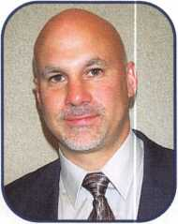

Read on and learn!

Keynotes • February 2004

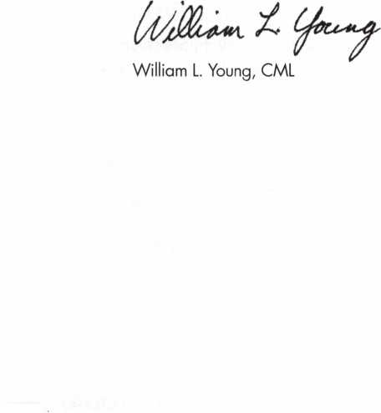

***Visit our Website on  
www. stamcctv. com***

**THE COMPLETE**

**CCTV PROGRAM ON CD-ROM  
FOR STAFF TRAINING AND**

**PRODUCTIVITY ENHANCEMENT**

STAM Insight has been  
developed to enhance CCTV  
skills and productivity with  
many different uses.

Ill Productivity

HI System Drawing €1 Estimation H CCTV Training # CCTV Reference I# Sales/Demo **III** System Design H Staff Evaluation

10 hours

14 hours

**CC7V** Content

CCTV Calculators

Demonstration Tool

Estimation

Drawing

Internet *Enabled*

***Pre-***Test

Quizzes

Sold

Distributed by:

3003 Live Oak Street  
Dallas,Texas 75204

Over 50 Countries

■ Yes, please send me a FREE PREVIEW CD ROM $9.95 S/H

Name:

Job Title:

Organization:

Address:

Zip/Postcode

e-mail

Fax: ( )



COPYRIGHT © 1996 Security Training and Marketing Pty Ltd. All rights reserved ACN 057 006 541

Country

Tel: ( )

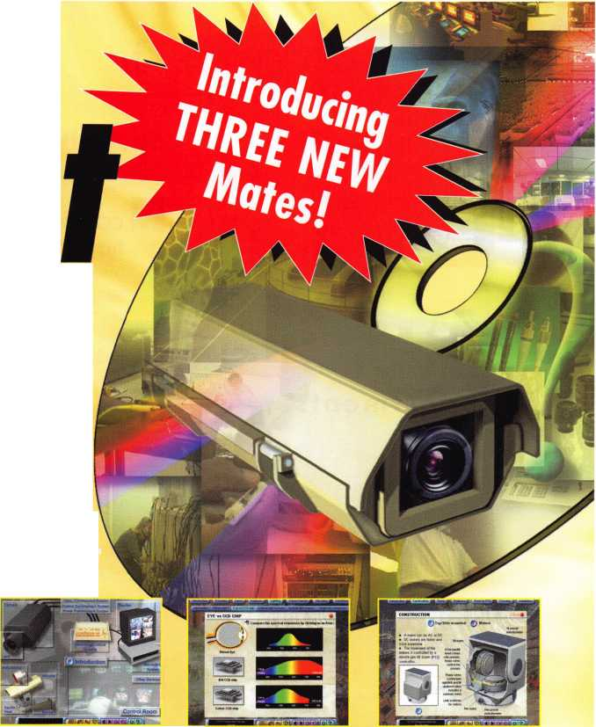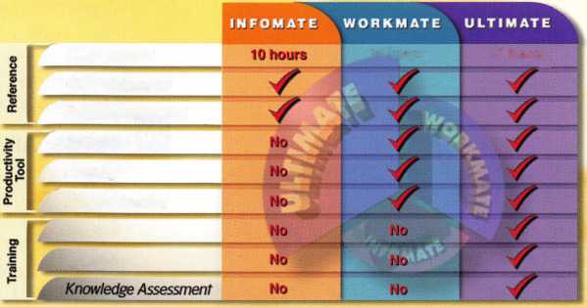

e

a

t

u

**res**

Specialty Locks

**departments**

Executive 5

Applicants 6

Calendar 8

Core 10

Legislative Update 38

Classifieds 40

Associate

Members 42

|  |  |
| --- | --- |
| r |  |
| Ad Index |  |
| Strattec Inside Front Cover | |
| A & B Safe | 1 |
| Stam | 3 |
| Turn 10 | 9 |
| Hinge Doctor | .35 |
| Professional Business Products | .41 |
| L | j |



COVER: Authorized Personnel Only!

Installing an X-08 on a Top Secret Government Door

Military facilities frown on photographs in their buildings, for any rea­son. But our team managed to soothe whoever was in charge by promising not to take photos of the contents of the room, but to only photograph the door and the lock as they were installing it. (Even this had to go through channels for approval.) Lets take a peek inside.

By Eric Costley, CRL

GREG'S CORNER: Specialty Locks: Luggage Padlocks and Then Some

CCL is now manufacturing a couple of padlocks specifically market­ed for luggage. Master Lock also produces a luggage padlock.

Well look at decoding the locks for lost or forgotten combinations. These locks retail for under $7.99. Its hard to justify any time to decode the locks, but its nice to see the inside just for fun, and occa­sionally someone will want one opened without damage. Knowing how they operate makes decoding easier. Well also look at some cabinet locks from Olympus and Keedex, and take a look at the Johnny Latch, from Jake.



**26**

By Greg Perry, CML, CPS

SPECIALTY LOCKS: New Key Control From Master

Master Lock now holds a pending utility patent on a new locking mechanism that is only available to the locksmith and industrial dis­tributor. Called the ML® system - after the profile presented by the end of the new key - this new system includes special features in the key section and keyway that are associated with the secondary lock­ing mechanism. Well give you an overview of it here.

By Billy B. Edwards Jr., CML

AUTOS: All About Honda

**30**

As one of the most common import vehicles locksmiths service,

Honda cars rank right near the top. And right up until the introduction of their transponder-equipped models, they were typically the easiest to service. From 1990 to 2002, the same key code series (5001- 8442) and system were used on all Hondas produced or sold in North America. Starting in 2002, while the 5001-8442 series con­tinued to be employed in most of the Honda models, a new high security key and key code series (K001-N71 8) was introduced.

By Tom Seroogy

SAFES: Safe Servicing and Combination Changing, Part 2

Servicing and changing combinations on home/office safes and  
vault doors is a very lucrative part of the locksmithing industry.  
Though the wave of the future of our industry is electronics, mechani-  
cal combination locks are still in abundance in the marketplace and  
probably always will be. Let us first examine the definition of safes  
and how the mechanical imperfections work to our advantage as  
security professionals.

By Jim Hancock, CRL

Visit our website at [www.aloa.org](http://www.aloa.org)

**executive**

Volume 50, Issue 2



Additional contact information for the ALOA Board and most Keynotes authors is  
available through "Locksmith Search'" on the ALOA Web site- [www.aloa.org](http://www.aloa.org) or by  
contacting the ALOA office at 3003 Live Oak Street; Dallas, TX 75204; (800)532-2562;  
FAX (214)827-1810; e-mail [aloa@aloa.org](mailto:aloa@aloa.org).

|  |  |
| --- | --- |
| Editor  Jim DeSimone | [editor@aloa.org](mailto:editor@aloa.org) |
| Technical Editor  David Lowell, CML, CMST .... | [david@aloa.org](mailto:david@aloa.org) |
| Editorial Advisor  John D. Cannon, CML | .[jdcannon@worldnet.att.net](mailto:jdcannon@worldnet.att.net) |
| Art Director  Betty Henderson | [betty@aloa.org](mailto:betty@aloa.org) |
| Advertising Sales  Kim Hammond | voice: 817-645-6778  Fax: 817-645-7599 e-mail: [adsales@aloa.org](mailto:adsales@aloa.org) |
| Executive Director  Charles W. Gibson, Jr., CAE | [charlie@aloa.org](mailto:charlie@aloa.org) |

Convention & Meetings Manager

Jo Anne Mims [joanne@aloa.org](mailto:joanne@aloa.org)

PRP/Education Manager

David Lowell, CML, CMST [david@aloa.org](mailto:david@aloa.org)

Operations/Membership Manager

Mary May [mary@aloa.org](mailto:mary@aloa.org)

Government Relations Manager

Paul Kanitra [paul@aloa.org](mailto:paul@aloa.org)

IT Operations Manager

Greg Jackson [greg@aloa.org](mailto:greg@aloa.org)

Comptroller Kathy J. Romo

Membership Coordinator Shelly Jett

Convention & Meetings Assistant Karen Lyons

PRP/Education Coordinator Esperanza Rodriguez

Accounting Coordinator Stephanie Brothers

Mail Room Coordinator Kevin Wesley

Receptionist Bryan Dease

Contributors

Jerome Andrews, CML  
Paul Chandler, CRL  
Claire Cohen, CML  
Brian Costley, CML, CMST  
Eric Costley, CRL

Ray D'Adamo, CML Sal Dulcamaro, CML Billy Edwards, CML Dan Graffeo, CRL,CMST Jim Hancock, CRL

AJ. Hoffman, CML Jeff Nunberg, CML, CMST Randy Simpson, CML Robert Stafford, CML Dave Thielen, CML

Greg Perry, CML,CPS Tom Seroogy Charles Stephenson, CPS Dennis Watanabe, CML, CMST

Mission Statement: The Associated Locksmiths of America, Inc. is dedicated to enhancing the professionalism, education and ethics among locksmiths and those in related sectors of the physical security industry. With approximately 10,000 members in the United States, Canada and the freeworld, ALOA is poised to help members obtain the knowledge, the strength, and the confidence to perform their role in the physical security field with pride and dignity. But it is only through active involvement and participation that ALOA can fully achieve its potential—and can help members to achieve theirs.

Policies: Keynotes® is the official publication of the Associated Locksmiths of America, Inc. (ALOA). Keynotes® acts as a moderator without approving, disapproving, or guaranteeing the validity or accuracy of any data, claim, or opinion appearing under a byline or obtained or quoted from an acknowl­edged source. The opinions expressed by the authors do not necessarily reflect the official views of ALOA. Also, appearance of advertisements and new products or service information does not constitute an endorsement of products or services featured by the Association. The Association does not accept responsibility for the inaccuracy of any data, claim, or opinion appearing in this publication, due to typographical errors on the part of the authors, Association staff or its agents.

Editor's Note: This publication is designed to provide accurate and authoritative information in regard to the subject matter covered. It is provided and disseminated with the understanding that the publisher is not engaged in rendering legal or other professional services. If legal advice and other expert assistance is required, the services of a competent professional should be sought.

Authors' Payment: Payment for eligible submissions to Keynotes will be based on the following criteria: topic, time spent and past contributions. Authors who regularly submit to Keynotes® are generally paid a higher rate. The latter is especially true of authors who write to fit specific editorial needs and submit said copy by Keynotes® deadlines. As a general guideline: Average payment for a 750 word, business or light' technical article would be $200. Payment for a 1500 word article involving significantly higher time and research efforts would be $400.

Payment will not be offered for articles submitted by ALOA employees or members of the ALOA Board of Directors (unless material is of a technical nature), nor for articles submitted by a company that promote that company's products or services. ALOA reserves the right not to pay for articles sub­mitted by an individual(s) that promote a particular company's products or services.

Disclaimer: The Associated Locksmiths of America, Inc., (ALOA), reserves the right to refuse any article for any reason. Additionally, ALOA reserves the right to edit, amend or modify any article submitted for publication in order to preserve technical accuracy, clarity, fairness or grammatical cor­rectness. ALOA will make the best efforts to notify the author of any changes. The extent of ALOA's liability for any article or information contained therein will be a notice of correction or retraction in the next possible issue.

Keynotes® (ISSN 0277 0792) is published monthly except for the combined June/July issue by The Associated Locksmiths of America, Inc., 3003 Live Oak St., Dallas, TX 75204-6186. Telephone: (214) 827-1701; FAX (214) 827-1810; e-mail [aloa@aloa.org](mailto:aloa@aloa.org). Subscription rates for members—$15.00 per year. Periodical class postage paid at Dallas, Texas. POSTMASTER: Send address changes to: Keynotes, 3003 Live Oak St., Dallas, TX 75204-6186. © Copyright 2003, All rights reserved. No part of the contents may be reproduced or reprinted in any form without prior written permission of the publisher.

President

William L. Young, CML  
(610)647-5042  
[president@aloa.org](mailto:president@aloa.org)

Secretary

John D. Cannon, CML  
(703) 960-6413  
sec reta ry@a loa. org

Directors/ Northeast

Robert E. Mock  
(856) 863-0710  
nedirecfor@aloa .org

Peter Sarailian, CRL  
(973)890-9797  
ned i rector@a loa. org

William L, Yol|§§ CML

(610) 647-5042  
[nedirector@aloa.org](mailto:nedirector@aloa.org)

Directors, Southeast

Tom Gillingham, Jr., CML, CPS  
(615)264-0747  
sedirector@aloa .org

Ken Kupferman, CPL  
(813)961-5784  
sedirecfor@a!oa .org

Directors, North Central

Mark E. Blum, CML, CPS  
1517} 482-5809  
ncd i rector@aloa. org

John Soderland, CML, CMST  
(414)327-5625  
ncd i rector@aloa. org

Director, South Central

CD Lipscomb, CML, CBS

(903)874-3522

[scdirector@aloa.org](mailto:scdirector@aloa.org)

Directors, Southwest

Gordon R. Racine, CML  
(719) 384-4707  
swdirector@aloa. org

Julie McCtuney, CRL  
(714) 636-5652  
swd i rector@aioa. org

Director, Northwest

Scott L. Henke, CPL CPS  
(907) 248-3785  
[nwdirector@aloa.org](mailto:nwdirector@aloa.org)

Director, European

Hans Mejlshede, CML  
(453)539-3939  
[eurdirector@aloa.org](mailto:eurdirector@aloa.org)

Director, Asian

JoeJ. Lee, CRL  
(215)289-2404  
[asiandirector@aloa.org](mailto:asiandirector@aloa.org)

Director, Associate

Paul M. Justen  
(800)333-6953  
asdirector@aloa .org

Trustees

trus [tees@aloa.org](mailto:tees@aloa.org)

. Randy Simpson, CMI  
(281)240-5959

JohnJ. Greenan, CML, CPS  
(773) 486.2030

Dallas Brooks  
(334) 826-8990

Past Presidents

2001 -2002 Randy Simpson, CML 1999-2001 John Greenan, CML, CPS 1997-1999 Dallas C. Brooks 1995-1997 David Lowell, CML, CMST 1993-1995 Breck Camp, CML 1991-1993 Henry Printz, CML 1989-1991 Evelyn Wersonick, CML, CPS 1987-1989 Leonard Passarello, CPL 1985-1987 Joe Jackman, CML 1983-1985 Stanley Haney, CPL 1981-1983 Louis LaGreco, CPL 1979-1981 John Kerr, RL . 1977-1979 Clifford Cox, CML

1974-1977 Charles Hetherington 1972-1974 Gene Laughridge 1 19701972 William Dutcher, RL

1968-1970 Constant Maffey, RL  
1966-1968 Harold Edelstein, RL  
1964-1966 William Meacham  
1962-1964 Robert Rackiiffe, CPL  
19601962 Edwin Toepfer, RL  
1956-1960 Ernest Johannesen

\

Keynotes • February 2004

**5**

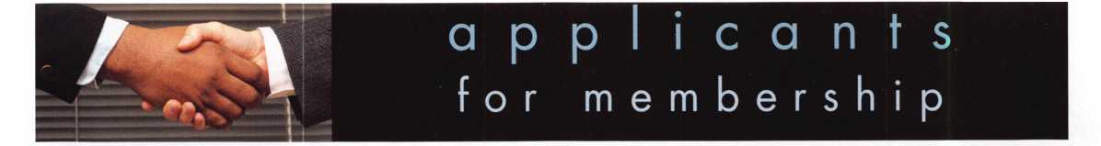

AK

MN

VA

Sitka

Jerold Deppa

AL

Dothan

Clifford Dean

Sponsor: James D. Turner Jr, CML, CPS

Craig McDaniel

Sponsor: Amanda S. Turner

AZ

Phoenix

Dennis J. Campbell Jr

Sponsor: William Lee CRL

William J. Adams

Sponsor: William Lee CRL

Steven R. Baldwin

Sponsor: Wayne R. Stuart

CA

Pinedale

Lisa M. Guzman

Sponsor: Noa Kristi

Redwood City

Mark Weiss

San Bruno

William J. Kane

Sponsor: Stephen Shields

co

Denver

Jeffry S. Kerns

Sponsor: Carl J. Haynes CRL

Greeley

Nick Jantz

Pueblo

Keith Burton

Sponsor: James A. Burton CPL

Steamboat Springs

Dennis Glackin

Sponsor: Lee A. Schoeneman CML

FL

Jacksonville

Keith E. Rahn

Sponsor: Bruce T. Rahn

Athens

Anthony Frank McDade

IL

Crete

Robert Rice

IN

Gary

Alex D. Matlock

Sponsor: Jim Williams CRL

LA

Shreveport

Neal McMahon

Sponsor: James L. Queen CML

Clifford D. McMahon

Sponsor: Mark A. Queen

MA

Adams

Robert J. Ciempa

Sponsor: Elliott S. Lubin

MD

Brandywine

Charles Dickerson

Sponsor: Lance A. Edwards

Silver Spring

Clifford Wood David O. Moore

Sponsor: Timothy M. Matthews

ME

Glenburn

Michele Perkins

Sponsor: Winfield F. Murray

Springvale

Tammy M. Hilton

Sponsor: Carol A. Atwell

Ml

Grand Haven

David Vandervelde

Sponsor: William L. Young CML

Rockford

Joshua D. Lepowsky

Sponsor: Leo E. Volkmann CRL

MO

Saint Peters

Marshall Heare

Sponsor: Shane M. Varney

NV

Las Vegas

Jeff Alamo

Sponsor: Kirk A. Miley CPL

NY

Buffalo

James R. Miller

Sponsor: Christopher M. Griesbaum CRL

OR

Salem

Steven Clark

Sponsor: James G. Jennings CRL

PA

Harrisburg

Andrew Youtz

Sponsor: David A. Firestone CPL

TN

Jackson

Thomas Tyler

Sponsor: Gary S. Mooney

TX

Dallas

Joe W. Johnson

Sponsor: Mark Caudill CRL

Hughes Springs

David Neill

Sponsor: John F. Sartain Jr

Alexandria

Deborah Snyder

Charlottesville

David Sanford

Sponsor: Daniel M. Brown

Richmond

John M. Dietrich

Sponsor: Mark A. Slater

Virginia Beach

Stanley Green

WA

Wenatchee

Jared R. Birks

Sponsor: Clay D. Howard CPL

wi

Fall Creek

Kenneth R. Mason

Sponsor: John S. Dorsey CML, CPS Sponsor: Kenneth W. Briggs

Fond Du Lac

Eugene D. Joyce

Sponsor: John F Engel CRL

Green Bay

Kathleen Mielke

Sponsor: Thomas G. Vandersteen CML, CPS Madison

Justin D. Linden

Sponsor: Tom Ripp



Whitley Bay, Tyne & Wear

Peter Price

London

Chris Von Cossel

Great Britain

Worle North Somerse

Roy King

Sponsor: Ken Dale

These applicants are scheduled for clearance as members of ALOA. The names are published for member review and comment within 30  
days of this Keynotes issue date, respectively, to ensure applicants meet standards of ALOA's Code of Ethics. Protests, if any, should be  
addressed to the Membership Department and must be signed. Active Membership applicants (a) have worked in the industry two or more  
years. Allied Membership (AL) applicants are not locksmiths, but work in a security-related field. Apprentice Membership (AP) applicants

have worked in the industry less than two years.

Keynotes • February 2004



Get ready for ALOA  
2004 - the biggest

security event in the  
world! ALOA will  
land in Baltimore's  
famed Inner Harbor  
to stage classes,  
workshops and

Get It... exhibits that will help

you shine in today's

marketpl

ace.

4U-044 '04

b4U-TtWORE, **Mp**

get *it... together*

The ALOA Convention and Security Expo • Baltimore Convention Center • July 19-25, 2004  
(800)532-ALOA(2562) • [convention@aloa.org](mailto:convention@aloa.org) • vAvw.aloa.org

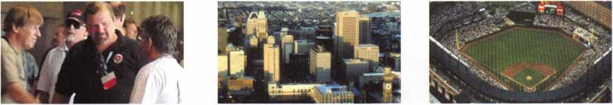

upcoming events

West Michigan Locksmiths Assoc.

Kalamazoo, Ml  
Mark Blum  
517-482-5809  
[callmark@sbcglobal.net](mailto:callmark@sbcglobal.net)

25-28 TLA Convention Galveston, Texas Tremont Hotel

28

Central & Southern Colorado Locksmiths PRP Sitting

28-29 Nutmeg Chapter of ALOA Laguard classes Berlin, Conn. 203-237-4602

Minnesota Chapter Regular Meeting Dave Nissen

mnchapternews@aol .com

11-13 California Locksmith Assoc Convention Ontario, California

12-14 Education Weekend Minnesota Chapter Dave Nissen

[mnchapternews@aol.com](mailto:mnchapternews@aol.com)

26-27 LASA

San Antonio • Two classes Contact Steve Morse Phone #512-353-8615 topnotch@thrifty. net

Minnesota Chapter Regular Meeting Dave Nissen mnchaptemews@aol .com

|  |  |
| --- | --- |
| 16-18 East Coast Regional | 24-25 Alabama Locksmith Association |
| Locksmith Convention | Membership Meeting, Dinner, |
| Somerset, New Jersey | Discussion & Seminars |
|  | Call 1-800-893-5487 |

**UPCOMING PRP SITTINGS**

|  |  |
| --- | --- |
| 2/8/2004 | Oklahoma City, OK • OMLA Convention Mike McGrew • 918-333-9136 |
| 2/12/2004 | Dallas, TX • ALOA  Hope Rodriguez • 800-532-2562x30 |
| 2/28/2004 | Locksmith Security Assn.  Maurice Horne, CML • 313-550-5810 |
| 2/28/2004 | Colorado Springs, CO  Central & Southern CO Locksmith Assn. Gordon Racine, CML • 719-384-4707 |
| 2/29/2004 | Texas Locksmiths Assn.  Butch Titus • 210-649-2166 |
| 3/11/2004 | Dallas, TX • ALOA  Hope Rodriguez • 800-532-2562x30 |
| 3/14/2004 | Maplewood, MN  Minnesota Chapter of ALOA  Dana Lee, CML • 612-968-4500 |
| 3/27/2004 | Reno, NV • Safetech 2004  Hope Rodriguez • 800-532-2562x30 |
| 4/8/2004 | Dallas, TX • ALOA  Hope Rodriguez • 800-532-2562x30 |
| 4/17/2004 | Somerset, NJ • MLANJ Convention  Bill Timmann, CML • 610-253-2325 |

|  |  |
| --- | --- |
| 5/13/2004 | Dallas, TX • ALOA  Hope Rodriguez • 800-532-2562x30 |
| 6/10/2004 | Dallas, TX • ALOA  Hope Rodriguez • 800-532-2562x30 |
| 7/8/2004 | Dallas, TX • ALOA  Hope Rodriguez • 800-532-2562x30 |
| 7/23/2004 | Baltimore, MD  ALOA2004 Convention  Hope Rodriguez • 800-532-2562x30 |
| 8/12/2004 | Dallas, TX • ALOA  Hope Rodriguez • 800-532-2562x30 |
| 9/9/2004 | Dallas, TX • ALOA  Hope Rodriguez • 800-532-2562x30 |
| 10/14/2004 | Dallas, TX • ALOA  Hope Rodriguez • 800-532-2562x30 |
| 11/11/2004 | Dallas, TX • ALOA  Hope Rodriguez • 800-532-2562x30 |
| 12/9/2004 | Dallas, TX • ALOA  Hope Rodriguez • 800-532-2562x30 |

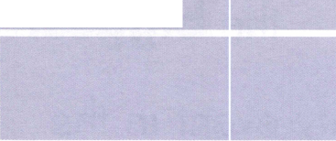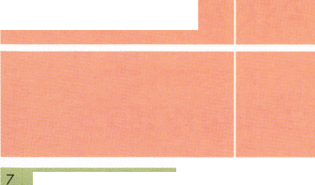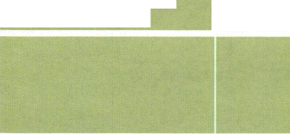

**IN-STOCK...MORE SAFES**

***FREE Freight Program***

***(30 States)***

**AMSEC FireKing  
fiarHall HAYMAN  
MEILINK** y/CTOR

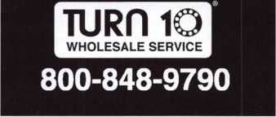

**UPCOMING ACE CLASSES**

2/24-27/2004

3/12-14/2004

7/18-25/2004

10/25-30/2004

GALVESTON, TX • TEXAS LOCKSMITHS ASSN.

Butch Titus • 210-649-2166

Investigative Locksmithing I Automotive Key Generation  
Electronic Safe Lock Servicing & Troubleshooting  
Small Format 1C • Investigative Locksmithing II  
Advanced Transponders • Combination Lock Servicing &  
Troubleshooting • Large format 1C • Investigative Locksmithing III  
Keyless Remotes & Automotive Update • Safe Deposit Locks  
Motorcycle Locksmithing • Basic Safe Penetration • Tubular Key  
Locks • Basic Electricity

MAPLEWOOD, MN • MINNESOTA CHAPTER OF ALOA  
DANA LEE, CML • 612/722-9181

Complete Door & Door Closers • Foreign Automotive (2 days)  
Exit Devices

Baltimore, MD • ALOA 2004 Annual Convention and Security Expo

39 Seminars and Half Day Classes

DAVID LOWELL, CML, CMST • 800-532-2562x18

77 ALOA ACE CLASSES

[education@ALOA.org](mailto:education@ALOA.org)

APPLETON, Wl • Fox Valley Technical College  
Jerry Antoon P-920/735-2406 • F-920/735-2414

Locksmith  
Convention 2004

Celebrating 20 years of

III and interkey

Berlin, Germany

Estrel-Hotel

May 19-23, 2004

[www.elf2004.de](http://www.elf2004.de)



**core**

New Membership CD Out Now!

Be on the lookout for your renewal packets in the mail. They contain a jam-packed new CD-ROM ALOA reference tool. The CD contains a fully searchable updated ALOA Membership Directory, the ALOA Bylaws, the ALOA Code of Ethics, ALOA's Technical Standards, PRP information, an ALOA Scholarship Application, an ALOA Membership Application, information on the ALOA Convention and Security Expo, the ALOA Grievance Form, and all sorts of information on special discounts available to all ALOA members. ALOA has never put together a CD-ROM like this before, and we're very excited about delivering something as useful as this to our members' doorsteps. Look for it in the coming weeks!

MEMBERSHIP RENEWAL DEAL!!

Starting in January 2004, all ALOA members who renew for the year will receive a $15 discount off ClearStar membership (currently $45). This includes new and renew­al memberships with ClearStar. Application must be made through ClearStar: [www.security](http://www.security) @clearstar.com.

CONTACT YOUR REPRESENTATIVE TODAY REGARDING "The Motor Vehicle Owner's Right to Repair Act" (H.R. 2735)

The Motor Vehicle Owners' Right to Repair Act (HR 2735) was reintroduced in July of 2003. As of this printing, the bill has 76 co-sponsors - but we need more to pass it. Many of you are familiar with the bill, but for those of you who are not:

HR 2735 gives the owner of the vehicle the repair, service and parts replacement information to his own property, this time vehicle. As you know, the car manufacturers have locked us out of many of the ignition systems so that their own car dealers - or the manufacturers themselves - are the only ones who can repair the ignition system, or duplicate keys. We're losing business. And, as new cars become older cars, we'll have even fewer to repair.

We need passage of HR 2735 in to ensure that the car manufacturers release the information we need to duplicate ignition keys and repair the systems. HR 2735 gives jurisdiction to the Federal Trade Commission (FTC) for oversight and enforce­ment, as well as allowing the FTC to set reasonable user information accessibility fees.

ALOA's POSITIVE ID POLICY:

* ALOA locksmiths are instructed to use the following positive identification policy when servicing lockouts:
* Notify Caller. When a call comes in to request lockout services, ask the caller if he/she has identification and authority to open the lock.
* Complete Form. Upon arrival at the job site, the locksmith should complete an Authorization Form that asks for the name, address, phone number, identifica­tion number and property description from the customer.
* Verify I.D. Verify the customer's photo-identification card and compare it to the information provided by the customer. If no photo-ID card is available, ask for some other reasonable form of ID.
* Verify Authority. The locksmith should inquire as to what authority the customer has to open the lock, and request to see any reasonable and appropriate evi­dence that could verify the authority. This may be impossible in some cases.
* Ask for Signature. Ask the customer to sign the Authorization Form, which should contain a statement that (a) the information given by the customer is cor­rect, (b) the customer has the authority to open the lock, and (c) the customer shall identify and hold harmless the locksmith against liability.
* Optional Last Resort. If you have any suspicions that the customer is giving false information or does not have authority to open the lock, say that you will be happy to open the lock provided a law enforcement officer is present. If the cus­tomer agrees, call the police; if not, leave.

File the Form. Keep the Authorization Form on file for a reasonable period of time.

New Certifications

Lorenzo White, CRL Detroit, Ml 48235

In Memory

James C. Ard, Sr., #1033 a long-time member in good standing of ALOA, recently

passed away. He opened Fludd's Security, Inc., in Florence, SC. On behalf of every­one at ALOA, we extend our sympathies to the Ard family.

A U.S. Senate Bill is expected to be introduced soon. HR 2735 is now in the U.S. House of Representatives Energy and Commerce Committee.

ALOA needs two action items from you to help pass this bill. First, log on to [www.righttorepair.org](http://www.righttorepair.org) and send a letter to your U.S. Representative and U.S. Senator asking them to cosponsor HR 2735. Next, it's vitally important for us to keep a paper trail of the keys we have not been able to duplicate, and other ignition systems prob­lems. PLEASE DO NOT THROW AWAY YOUR WORK ORDER IN THE EVENT THAT LACK OF AVAILABLE INFORMATION KEEPS YOU FROM REPAIRING A CUS­TOMER'S SYSTEM OR REPLACE THEIR KEY. Instead, copy it and fax it to the ALOA offices, attention Paul Kanitra, at 214/827-1810.

ALOA has been a coalition partner of The Coalition for Auto Repair Equality (CARE) to spearhead the effort to pass this important bill. We can't do it alone; please con­tact your legislators and fax us those work orders!

Thank you for your support. Don't let locksmiths get locked out of our own business!

Let Us Know!

If you have an opinion to offer on ALOA, the state of the industry, or life in general,  
we want to know about it! Submissions to the "Mailbox" section of Keynotes are  
printed on a space-available basis. Write to: "Letters to the Editor"; ALOA; 3003 Live  
Oak Street; Dallas, TX, 75240; FAX 214/827-1810; e-mail: [editor@aloa.org](mailto:editor@aloa.org).

Need Help?

At ALOA, we want to make sure you are getting as much bang for your membership  
dues buck as we are able to give you. If you have had problems getting membership  
services, or have a question regarding member services, please contact Bill Gibson,  
executive director, at 800/532-2562, or e-mail: [charlie@aloa.org](mailto:charlie@aloa.org).

Key Machine Winner!

Mark R Franko #11413  
A-Franko's Safe & Lock Company  
30 Cynthia St  
Waggaman, LA 70094

Note: Convention package drawing  
will be held after March 31.

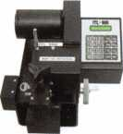

**MEMBERSHIP APPLICATION**



Welcome to the Associated Locksmiths of America, Inc., an association for persons involved in the security industry as  
locksmiths, security consultants, educators, manufacturers and distributors.

To apply for membership, please complete this application and submit it with the dues for the current year, and your  
business card, company letterhead, or other suitable proof of employment.

All of the following questions MUST be answered before this application may be processed. Please type or print.

TYPE OF MEMBERSHIP

Please check only one.

* ACTIVE MEMBERSHIP  
  Individuals actively engaged in  
  supplying, servicing, or installing  
  security hardware for a period of  
  not less than two years.
* APPRENTICE MEMBERSHIP  
  Individuals who are in initial train-  
  ing and meet all the requirements  
  for Active Membership except for

' the length of time in the security  
industry.

* ALLIED MEMBERSHIP  
  Individuals whose position in the  
  security industry relates to the  
  aims, policies and promotion of  
  the locksmith and his/her craft.

APPLICATION AND FEES

A $50 application fee, appropriate  
annual dues, and your business  
card, company letterhead, or suit-  
able proof of employment must  
accompany this application. Your  
second year's dues will be prorated  
based on the date your application  
was received by ALOA.

FINAL CHECKLIST u$

Dollars

* Application Fee 50.00

ANNUAL DUES STRUCTURE

* Active/Allied Member 155.00  
  U.S. + U.S. Territories

(PR, VI, Guam)

* Active/Allied Member 1 30.00  
  Non U.S. Resident or

Non U.S. Territories

* Apprentice Member 80.00

U.S. and International

OTHER FEES

* Canadian Air Mail 20.00
* Overseas Air Mail 50.00

Total Enclosed

**Return to**

**ALOA**

**3003 Live Oak Street  
Dallas, TX 75204-6185  
(214)827-1701**

CANDIDATE (PLEASE TYPE OR PRINT)

|  |  |  |
| --- | --- | --- |
| Name □ Mr. □ Mrs. □ Ms. | | |
| Business Name | | |
| Mailing Address | | |
| City | State Zip Code | Country |
| Work Phone | Home Phone | Fax |
| Email Address | Website |  |
| Date of Birth | Social Security Number |  |
| Directory Address (if different than mailing address) | | |
| City | State Zip Code | Country |
| □ Do Not List in Directory |  |  |
| PROFESSIONAL INFORMATION | |  |
| 1. Are you a...  □ Sole Owner □ Corporate Officer | 4. ALOA Sponsor | 5. Names and addresses of two industry-relat­ed references (required): |
| □ Partner □ Employee □ Student  2. Are you currently employed in the | Sponsor's ALOA Number | Name  Address |
| security industry?  □ no □ yes, years  3. How did you learn locksmithing or security work? | Please note, if you are sponsored by an ALOA member, your application will be immediately processed with a 90-day probation period. Otherwise, final processing takes up to 120 days. | Name  Address |

6. IMPORTANT: Have you ever been convicted of a felony? □ No □ Yes

If yes, please give details on a separate sheet. All felonies are reported to the Membership Department for review.

METHOD OF PAYMENT

□ Check □ MasterCard □ Visa □ Discover □ American Express

|  |  |
| --- | --- |
| Card Number | Expiration Date |
| Please print name as it appears on card |  |

Cardholder's Signature

I certify that all statements are true and, if accepted as a member, I agree to abide by the rules, regulations, and Bylaws of ALOA, and further agree to  
adopt the Code of Ethics of ALOA as my own, and adhere to it to the best of my ability. Should my membership be discontinued, I agree to return my mem-  
bership card, and cease use of all ALOA insignia.

Signature

Date

Revised 12/03

Installing the CD-X08

By Eric Costley, CRL

If you’ve ever done work for the government, you know the drill: Make four copies of the invoice, mark one “original,” throw one in the trash, put an “X” in the birthday box and wait 120 days for payment.

(Note: Offer them a .5 percent discount for payment in the next 10 days and they HAVE to take it; it’s a government thing.) Anyway, fortunately for me, I got to sit on the sidelines for this one. Mark Fuller, CPL, and Hank Fuller, CRF, had the joy of this adventure.

I am indebted to them for the few pictures they man­aged to snap and for the “inside dope” that makes up the majority of this article.

The CD-X-08 is a product that not many of us get to see: The $iyoo-plus U.S. cost intimidates all but those who must have such a product to meet government specifications for their particular application. Also, the CD-X-08 has now been replaced with the CD-X- 09, and were it not for the difference in the color of the dial ring and dial, you probably wouldn’t notice any difference. (I’m sure that some government “spook” somewhere knows exactly what the difference is and why the actual upgrade took place, but of course, they’re not talking.)

I mentioned earlier the lack of extensive photography for a reason: Evidently, military facilities frown on photographs in their buildings, for any reason. Mark and Hank managed to soothe whoever was in charge by promising not to take photos of the contents of the room, but to only photograph the door and the lock as they were installing it. (Even this had to go through channels for approval.) In an effort to maintain some semblance of security, I will refrain from any further mention of where this lock was actually installed.

And when. And for what reason.

The lock was to be installed on a solid wooden door with a metal frame. The lock was on site when my employers arrived, and the installation became a “carry out only what you carry in” affair. Even the cardboard box was left behind, so I can only describe for you some of the aspects of the installation that didn’t manage to get photographed.

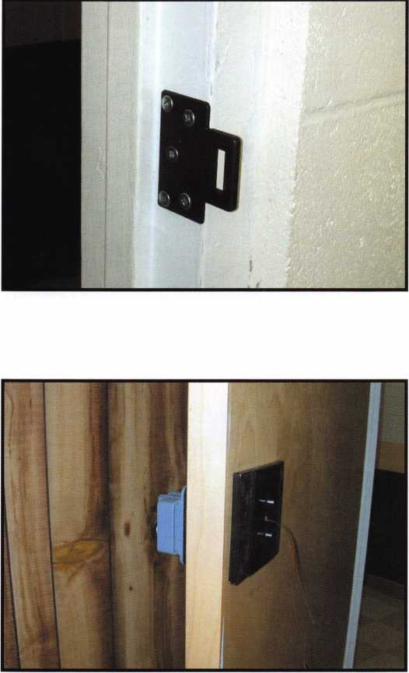

Photo 1 shows the door in question with a leverset installed, and the ominous ‘Authorized Personnel Only” sign. After a brief look at the door, frame, lock, templates and instructions, Mark and Hank decided that the installation would be fairly quick and easy. The mounting of the strike plate to the frame became the first order of business (Photo 2), and then the template came into play to mark for the actual lock mounting holes.

Only five holes are required to mount this lock: four to bolt the lock through the door, and one to accom­modate the spindle and wires. The four holes that mount the lock to the door (to the required hardplate

Keynotes • February 2004

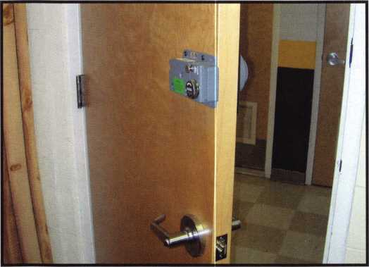

for this application, which adds another $300 or so to the price of the lock) require only quarter-inch holes. The hole for the spindle assembly and wires calls for a “3/8 inch or larger” hole; this means that installation on a fire-rated door is perfectly within the required specifications. Photo 3 shows the external hardplate installed and the inside lock body, with the wiring extending through the front of the door.

Here we need to pause. There are two tubes that go from the lock body through the door to the dial.

The inner tube contains the spindle itself, which pow­ers up the lock and retracts the bolt. The external tube houses the wires that transfer the energy of the spinning dial into an electrical signal, which generates the electricity necessary to power up the lock.

For those of you who might not know, one of the trademarks of the Kaba Mas line, (formerly Mas Hamilton,) is the fact that these locks require no external power source; that means no batteries!

The basic principle of the Kaba Mas line, since its inception, was to generate the electricity required to operate the lock simply by spinning the dial.

For those of you who are as old as I refuse to admit to being, the following scenario might cause a nostal­gic flashback.

My first bike had a wonderful headlight that was operated by means of what we referred to as a “mag­neto,” a primitive generator. The wheel of the genera­tor leaned against the tire of the bicycle, and the faster you pedaled, the brighter the light would shine. As you coasted to a complete stop, the light would fade, eventually dimming to complete darkness.

What was the brilliance of this idea? No batteries! Despite my obvious ties to S&G, I have to give a thumbs up to this innovation, and the fact that it has been out in the field, working, and is now required in some government applications proves that the inno­vation has proven itself. But I digress.

There are a few quirks involved in the installation of an X-08, (or the subsequent X-09,) that the ‘Average Joe” should know. (Why do I say this? Because I AM an Average Joe!) First of all, with “quirks” come

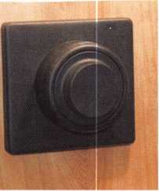

**14**

Keynotes • February 2004

“perks.” The X-08 comes with a few tools that make the job a little easier. There is a saw in the package for cutting off the tubes that extend from the lock body to the external dial, as well as a nice deburring tool that takes any rough edges off of these tubes, so that the wires don’t scrub against any nasty edges that might cause an electrical short. In addition, when you go to cut the tubes that go through the door to the proper length, there’s a rubber holder for the tubes that fits nicely in your vice, so that you don’t crush or distort the tubes while you are cutting them to the proper length.

Cutting these tubes to length, by the way, is critical. The wire/spindle tubes and the spindle must be either flush or “slightly less” than flush with the lock body so that the geared cam drive can be installed properly. The geared cam is tightened onto the spindle with two set screws, and over this, the dial is permanently snapped on. One gem of knowledge that my esteemed employers conveyed is that you don’t install the dial until you’ve tested the lock! Evidently, the instruction manual tells you to install the dial and then test the lock. Unfortunately, the dial cannot be removed with­out ruining it! The geared dial hub is plenty enough to test the lock with, so go ahead and do this ahead of time, saving you a headache and a potential liability. Once the dial is snapped on, you’re committed, so don’t forget: Test the lock FIRST!

Another thing about the X-08 is if you need to remove the back cover (and this by the way is LOBC, or “locked on by combination”), make sure to take the cover off straight and directly perpendicular to the lock body Lockmasters makes a special tool to make this effortless; evidently, one could easily cause dam­age to the lock if the cover is removed improperly

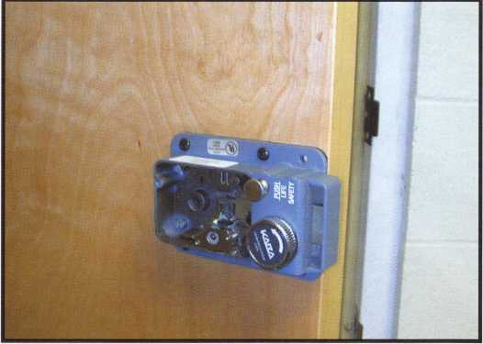

A few closing thoughts, concerning the operation of the lock: The LCD display on the face of the exter­nal dial ring is difficult to read, even if you’re the one standing directly over it! (Hey, it’s government, right? No surreptitious spying is a good thing!) A special tool — again, included in the box — is required for changing the combination or function of the lock.

Beyond the basic information that I’ve supplied here,

I would suggest that anyone dealing with such a beast, and requiring additional information, contact either Lockmasters or the manufacturer. There is quite a bit of information available for download from various Internet sites as well. As I would always rec­ommend when installing or servicing something unusual? Take photos, get some documentation, and cover your butt so that it doesn’t come back to bite you! Happy Installations!

About the Author: Eric Costley, CRL, has been active in the locksmith industry since 1980. He has a bachelor's degree from Gardner-Webb University; and has worked in shops in Arizona, North Carolina, and New York. He is currently employed by Bill's Locksmithing in Elmira, New York. Eric's hobbies include music and raising tarantulas.

Keynotes • February 2004

Specialty Locks:

Luggage Padlocks and Then Some

By Greg Perry, CML, CPS

**6**

Keynotes • February 2004

CCL is now manufacturing a  
couple of padlocks specifical-  
ly marketed for luggage.

Master Lock also produces a  
luggage padlock. The three  
locks and a Prestoseal can be  
seen in photoi. Let’s take a

look at all three, inside and out. Well  
look at decoding the locks for lost or  
forgotten combinations. These locks  
retail for under $7.99. It’s hard to justify  
any time to decode the locks, but it’s  
nice to see the inside just for fun, and

occasionally someone will want one opened  
without damage. Knowing how they operate  
makes decoding easier.

First is the Prestolock, model 2405. This is a three-dial  
combination padlock, and it also comes with a couple  
of Prestoseals. A Prestoseal is a plastic loop device  
that is a one-way seal. It is similar to a ty-wrap with a  
flag. These locks look and feel like most Prestolocks;  
they also decode like many of the three-wheel combi-  
nation locks. Looking beside the wheel on the side  
away from the shackle (with a bright light, and for  
some of us, magnification), we can see the inner hub.  
Photo 2 starts our look inside. Photo 3 shows the hub  
is keyed on the inside; when the inner key or pin is  
lined up with

the slot on the  
shaft, the shaft  
will slide  
through the  
hub. The out-  
side diameter  
of the hub has  
a slot or notch  
cut in it. It also  
has two pins  
that align or

key inside the number wheel.

Changing the position of the number wheel to the  
hub is how the combination is changed. The impor-  
tant part is the notch cut into the hub. It is 180  
degrees (or 5 numbers) different from the keyed pin

on the inside. Once we  
can see the notch on  
each wheel, the lock is  
open. Line all three  
wheels up and add five  
to the combination dis-  
played to open the lock.  
This is similar to the  
change hub of an S&G  
combination safe lock  
wheel; the change hub is

180 degrees away  
from the wheel  
gate. Changing  
the combination  
does not change  
the relationship  
of the change  
hub to the gate.

Changing the

number wheel on a Prestolock  
does not change the inner  
hub. The change slide on

these locks simply dis-

engages the number

wheel from the inner  
hub. You can now turn

the number wheels to a new combination.  
When you slide it back, the orientation  
between the hub and the number wheel  
is changed.

SearchAlert is a brand new padlock (seen in  
photo 4) designed to allow the TSA (Transportation  
Security Administration) to open the padlock without  
damage. It has a couple of unique features. First is the  
ability for the TSA to open the padlock with a  
“SearchAlert secured access device,” or key. This lock  
is labeled TSA 04, as seen in photo 5. I’m not sure



Keynotes • February 2004

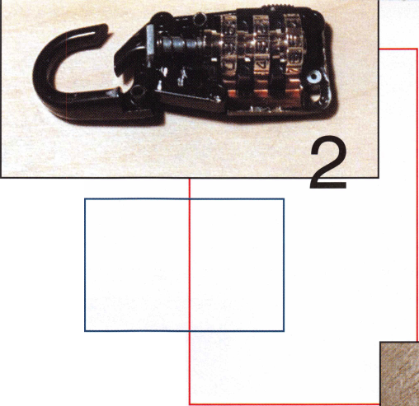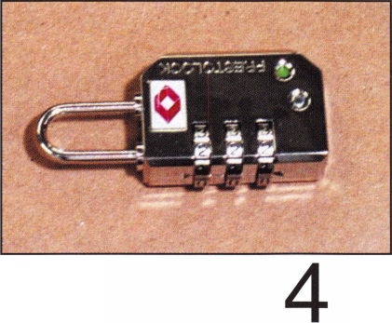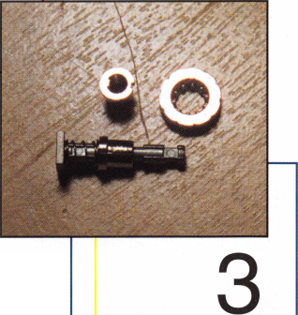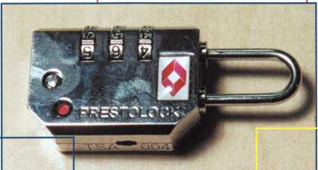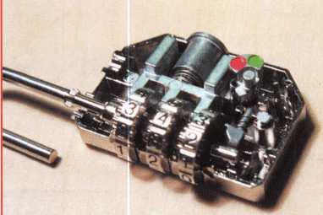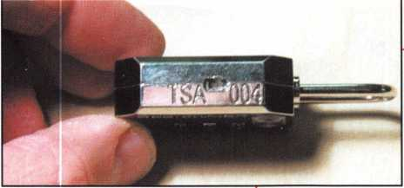

whether there is a  
TSA i, 2, or 3, but the  
first luggage key I  
tried off our keyboard  
turned and released  
the shackle. The sec-  
ond unique feature is

the indicator; it changes from green to red if the lock  
is opened with the key The red indicator can be seen

in photo 6. The inner mechanism seen  
in photo 7 has some similarities to the  
inner workings of a Prestolock with  
several differences. The first difference  
is that the shackle is the wheel shaft.

Second, as seen in photo 8, is the gate

on the gears, or inner hub,

is on the outside of the  
hub. The gates can be  
seen as you look beside  
the wheels on the side  
away from the shackle.

There is a gear tooth

missing on  
the gear.

Again, it  
helps to have  
a strong light  
and magnifi-  
cation. Once  
you have all  
three gates  
aligned, add  
five to the

numbers displayed to open the lock. The three fence legs enter the gates as you pull up on the shackle. The fence looks like back-to-back cap­ital E’s. The middle leg opposite the fence is threaded. The key is used to turn a nut to pull

away or disengage the fence from the hub

gears, allowing the shackle to pull out. At the

same time, as it is pulled away from the gears, a tab on

the bottom trips the  
indicator, moving it from  
green to red. The lock  
stays unlocked until the  
key is used to turn it  
back to the engaged, or  
locked, position.  
Resetting the indicator  
to green requires opening  
the lock with the combi-  
nation, turning the  
shackle 180 degrees and  
pushing the shackle in to  
the stop.

Next on our list is the luggage lock from Master. It operates simi­lar to the Prestolock, dial 3 numbers and push in on the

keeper. The difference is the wheels are in a flat plane to the lock instead of perpendicular. The wheels do not encircle a single shaft. Instead they each turn on there own shafts. Looking inside in photo 9 we see how the lock operates. Each wheel is comprised of three parts that can be seen in photo 10. First is the number wheel,

next is the hub and lastly, a spring to keep the two other pieces together. The gates

7

align to the shackle side of

the lock to allow the green

plastic slide to be pushed  
down into the hubs to open  
the lock. Like the Prestolock  
and SearchAlert locks, the  
hubs have the gates, and  
changing the combination is

\

**8**

Keynotes • February 2004

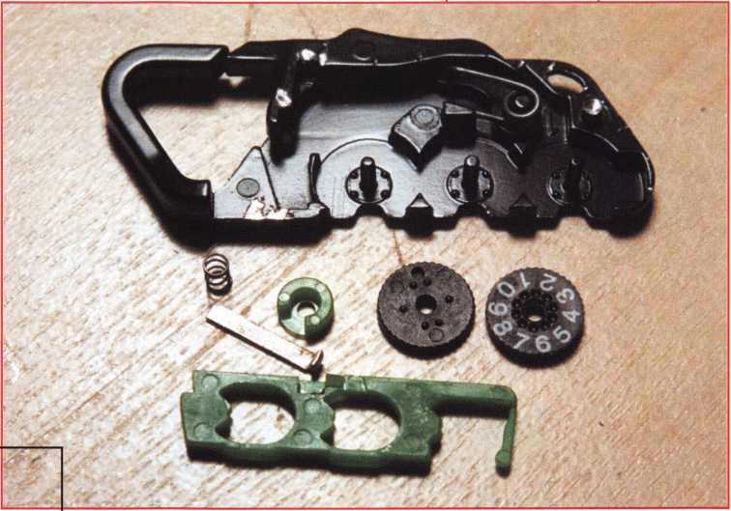

accomplished by moving the number wheel while  
holding the hub in place. The Master lock requires  
the shackle to be held open as you spin the number  
wheels to reset the combination. Opening a Master is  
made easier by the contrast of the spring seen below  
the hub in the gate opening. The gate can be seen  
below the number wheel in three different number  
locations. For example, if the combination is set on  
zero, the gate can be seen on numbers, six, seven, and

eight. The middle number is  
easiest for seeing the gate and  
the spring beneath it. Align all  
three hubs to the same middle  
location, and then add three  
numbers to open the lock.

These locks, although inexpen-  
sive and generally easy to open,  
are produced in large quanti-  
ties, meaning you’ll likely see  
them in your shop with lost or  
forgotten combinations.  
Learning how easy they are to  
decode can add a few dollars to  
your cash register.



Keynotes • February 2004

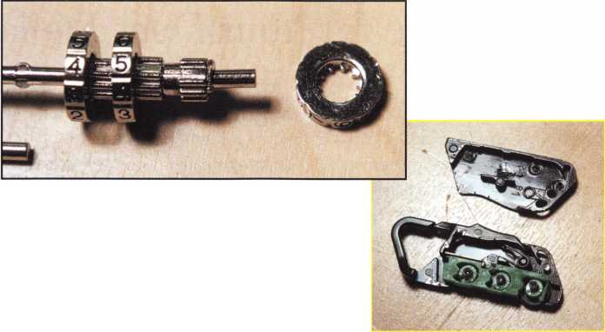

More for

A few new products have  
come out since the ALOA con-

vention in Las Vegas last summer,  
when I wrote my last article on new

products. Let’s look at them, and a couple  
of other products that have been on the mar-

ket for a while. We’ll look at a couple of cabinet

lock goodies, one from Keedex and the other from

Olympus. Finally we’ll install a Johnny Latch by Jake.

Keedex, the maker of many labor-saving tools and parts, has made our lives a little easier with a cabinet lock strike. I’ve made similar strikes in the field out of aluminum angle; however, the time spent making them is not always cost effective. This strike has two slots for adjustment and a center screw hole to lock the strike in position. It will work with cam locks, drawer and desk locks; the part number is: BRCAM. They are available in packs of two.

Next up are a couple of time savers from Olympus. Have you ever splintered the front of a nice oak desk drawer (or other fine cabinet) as you were drilling to install a cabinet lock? Or, have you ever felt the need to provide a better mount on particleboard? Olympus has come out with the ETS line of outside reinforcing

Your Dues Dollar ...

escutcheons and drill guide templates for better accu­racy. The templates can also be used as spacers. Another product from Olympus we’ve been using for years is the white plastic WP21 spacer. They come in handy to space locks away from the door or drawer. They’re very inexpensive and save time by eliminating the need to make your own; Olympus also makes a larger one for use with the large size drawer locks.

The Johnny Latch by Jake has been on the market for a few years. Recently, a church called; it seems the pastor doesn’t like being walked in on while — shall we say -- “indisposed” in the bathroom stall. They want­ed a new lock on the bathroom stall door, now! I looked for a name on the bathroom hardware; of course, the manufacturer was not proud enough of their work to sign it. I contacted Lockmasters, who now distributes the Johnny Latch. This product claims to work on any bathroom stall door. Opening the package revealed six aluminum parts and two screw packs. Also available are adapter plates for cov­ering holes in doors from the old hardware.

The lever is attached to the inside escutcheon first after determining the hand and swing of the door.

The inner and outer escutcheons look identical,

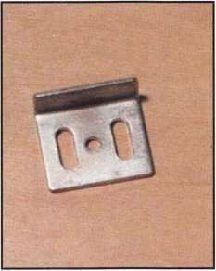

Keedex, the maker of many labor-sav­ing tools and parts, has made our lives a little easier with a cabinet lock strike.

Keynotes • February 2004

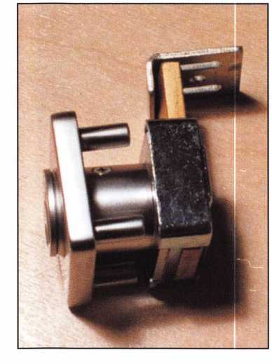

except one has double-sided tape on the backside.

The instructions don’t mention which one to use first, so you need to look at the pictures to see that the escutcheon without the tape is used with the lever on the inside. Since this is an out-swing door, the outer escutcheon is attached aligning the notches on the plate with the edge of the door using the double-sided tape. Next, five ?-inch holes are drilled through the door, and the center hole is enlarged to 7/16-inch to allow clearance for the nut from inside lever bolt. Assemble the inside lever and escutcheon to the door and outside escutcheon with the binder posts (small through bolts) and the inside screws.

Next, install the strike/keeper using the 3 included round head screws. In this case the lever did not have enough clearance once the strike was installed. The lever assembly needed an additional washer added between the lever and the inside escutcheon. I also tightened the nut a little more, for tension. Once the lever assembly was reinstalled, it still bound on the

Olympus has come  
out with the ETS  
line of outside rein-  
forcing escutcheons  
and drill guide tem-  
plates for better  
accuracy

middle screw, requiring the use of a flathead screw and binder post. Total install time was about 30 min­utes. The Johnny Latch by Jake is a unique product that fills a niche of parts not normally available to the locksmith market. To fit on all the different configu­rations, it comes with a few extra parts. It might take a few minutes to figure out which parts are needed from the assortment. Their web site, [www.johnny- latch.com](http://www.johnny-latch.com) offers more instructions; however, on-the- job web sites are not often available.

None of these products is going to make you rich, but each can add to your bottom line and sometimes save you a significant amount of time. Until next time ...

About the Author: Greg Perry\ CML, CPS, has been in the locksmith indus­try for 20 years. He's spent half of that time as a field technician for Security Engineering in Ridgecrest; CA. Greg is also a past president of the Desert Counties Chapter of the California Locksmiths Association. He has also won the 2002 and 2003 Keynotes Author of the Year Award.

You can e-mail him at [glmperry@iwvisp.com](mailto:glmperry@iwvisp.com).

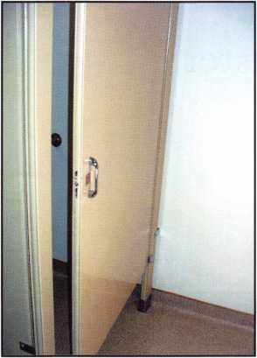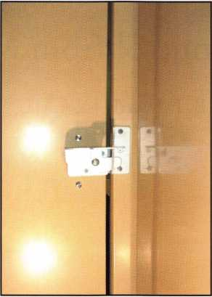

The Johnny Latch  
by Jake has been  
on the market for a

few years.

Keynotes • February 2004

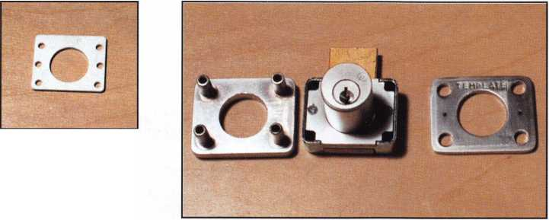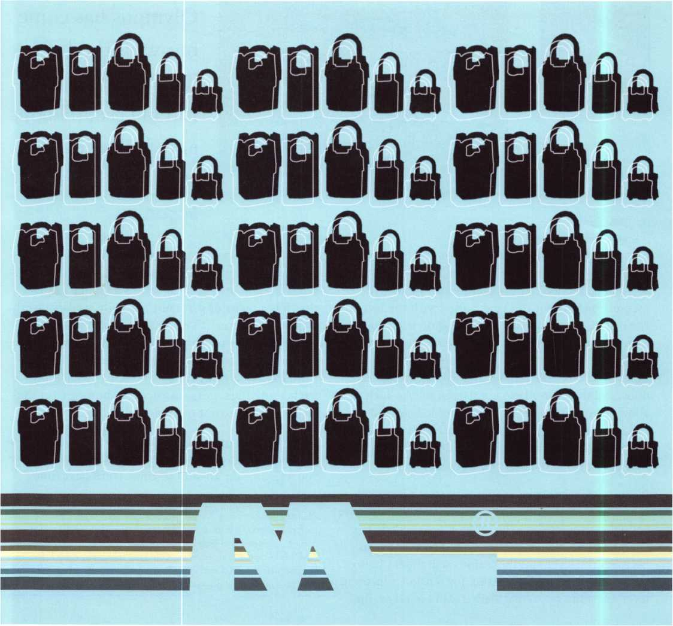

New Key Control from Master

By Billy B. Edwards Jr., CML



Keynotes • February 2004

Master Lock now holds a pending utility patent on a new locking mechanism that is only available to the locksmith and industrial distributor. Called the ML® system — after the profile presented by the end of the new key - this new system includes special features in the key section and keyway that are associated with the secondary locking mechanism. That association will extend the utility patent protection to the key blanks, as soon as it is issued.

A four-pin or a six-pin cylinder is available, and the secondary mechanism basically offers a way to multi­ply the number of available keys. The secondary lock­ing mechanism consists of four 3/32-inch ball bearings, (two on each side of the key), that interact with the key in a specific way. Each bitting combination for the secondary mechanism will be used as a virtual keyway, and only made available to certain geographic areas.

In conjunction with each actual six-pin keyway there are no virtual keyways. To meet the needs of the mar­ketplace, those virtual keyways will be used to accom­plish four levels of key control.

smith to have the ability to provide controlled local service and to duplicate keys. An ID number is assigned to the locksmith and stamped by Master on all key blanks.

Level 3

This level of control is for the institutional end user who actually has a locksmith on-staff. A contractual agreement is required with Master Lock regarding the key control aspects and access to key blanks for the virtual keyway assigned. This level is designed for end users who want key cutting capabilities available in- house only. An ID number is assigned to the lock­smith and stamped by Master on all key blanks.

Level 4

This level of control involves virtual keyways that are factory controlled, and blanks will never be sold. Designed primarily for the end user who doesn't want any local capability for key cutting.

Level 1

A single generic virtual keyway known as EL will be available for locksmiths whose customers want the abil­ity to have keys made by any locksmith, but nowhere else. Anyone with a key can approach any locksmith to have a duplicate made without restriction. Designed to make service a locksmith-only situation.

Level 2

A selection of virtual keyways will be made available to locksmiths who are willing to make a contractual key cutting commitment with the distributor and Master Lock. The agreement has the typical require­ments for key control programs, such as record keep­ing, not cutting keys for locks sold by others, etc. It is designed for end users who want only their local lock­

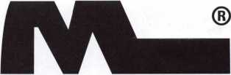

in photo 1, you can see what how the mechanism

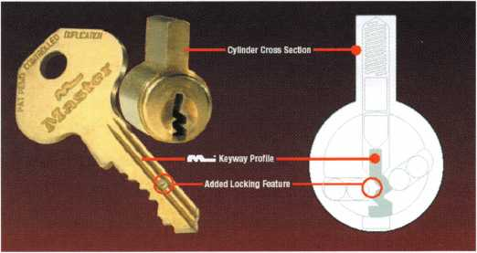

looks. Servicing of the cylinder is typically the same as it has always been, with three exceptions:

1. You need to be careful to not lose ball bearings when you follow the plug out of the shell. The ball bearings are not staked in place.

Keynotes • February 2004

1. Because the ball bearings need a slot in the shell to allow key withdrawal, it isn’t possible to rekey using the service holes on the bottom of the shell.
2. When Master Keying the new cylinders, a number one master pin cannot be used. The ball bearing slots in the shell would allow a number one master pin to leave the plug and jam the lock trapping the key

Master Lock Co. has a MK system generating service available if you don’t want to or can’t generate your own systems. Master will generate a system for you and supply an electronic copy of it for your use. Master will not retain a copy of the system.

All bitting specifications are the same as for the ProSeries® 6000 and 7000 keys with the round back keys. All keying may be accomplished using the cur­rent 291-pin kit. The ML® series cylinders are avail­able in the full range of Master Lock commercial pad­locks to help you satisfy the requirements of your customers.

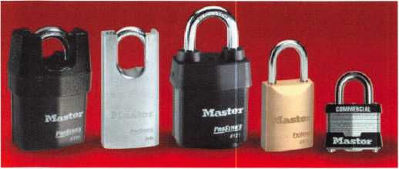

If you would like to order just the ball bearings to supplement your current pinning kit, the part number 296-0200 will get you a bag of 200.

What Else is New  
from Master?

Master Lock Co. has made  
some changes to their laminat-  
ed padlocks, which are sold  
only through locksmith and  
industrial distribution. You  
won’t see this new style of lam-  
inated lock in a retail outlet

unless it is a locksmith shop. The lock numbers 1, 3, 5,  
11, 15, 17, 21, 25, 27, 31 and 81 have been upgraded to a  
new version. If you want the old versions, they are  
only available as a retail product now that the running  
change has been accomplished for each model. Three  
important new features have been added to these  
locks to eliminate problems some customers may have  
been having.

First, even though Master padlocks have had plastic bumpers on them for more than 20 years, there are still applications where the top of the padlock body can scratch a painted surface. The new double bumper lock should eliminate that problem.

Second, the advent of the i8v portable drill has changed the difficulty level of drilling a laminated padlock; the second new feature should slow that drilling down again. The bottom plate of the lock has been replaced with one that has an hourglass keyhole. The new bottom plate has also been hardened, and the MSRP for these new 1, 3 and 5 locks is only one thin dime more than the retail version without the features.

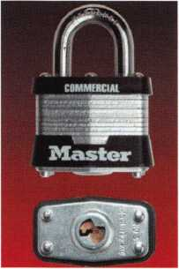

Keynotes • February 2004

Third, in the past, a destructive method of defeat has been to chisel off the rivet heads, pry the bottom plate off and remove the cylinder to access the bolt. The upgraded Commercial version has greatly improved resistance to those who would try to chisel off the rivet heads. They are countersunk into the bottom plate so that even if the head is attacked with a chisel the rivet will hold the bottom plate onto the body.

New news in com-  
bination locks

A new feature applied  
to the 175 resetable  
combination lock

that has proven

popular is the  
independent

key override. This new model is

called the 176 and the override cylinder is compatible

with our standard number 7 key.

The 176 may be ordered  
keyed to an existing key  
code or rekeyed in the  
field. The cylinder is  
mounted with a hex set  
screw that takes a 1.5mm

wrench. It can be found in the toe side shackle hole.  
To remove the cylinder for rekeying, first remove that  
set screw, then turn the cylinder plug and pull. The  
cylinder with its long tail plug will come out of the  
body easily and may be rekeyed through the service

holes in the bottom of the shell. To replace the cylin­der, just turn the key and insert and then restore the set screw.

This cylinder may be rekeyed using our 291 pinning

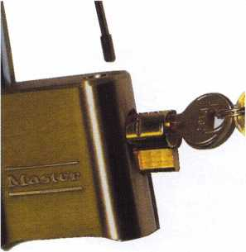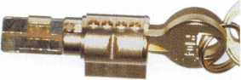

kit. It is compatible with the number 7 cylinders used in our gun locks, 7 and 8 padlocks, the new mini Python and 185 locks and may be rekeyed to any of their key codes.

About the Author: Mr. Edwards is the Key Records Manager for Master Lock Co. and has an extensive locksmith background. He is also the Chairman of the LIST Council and a past recipient of the coveted Philadelphia award. He has taught many factory certified training classes in the past and is now teaching for Master Lock Co. as well, check with your distributor or association for class availability.

Keynotes • February 2004

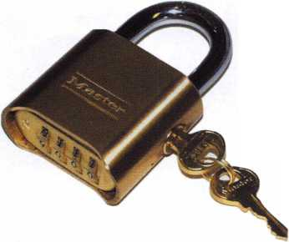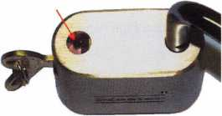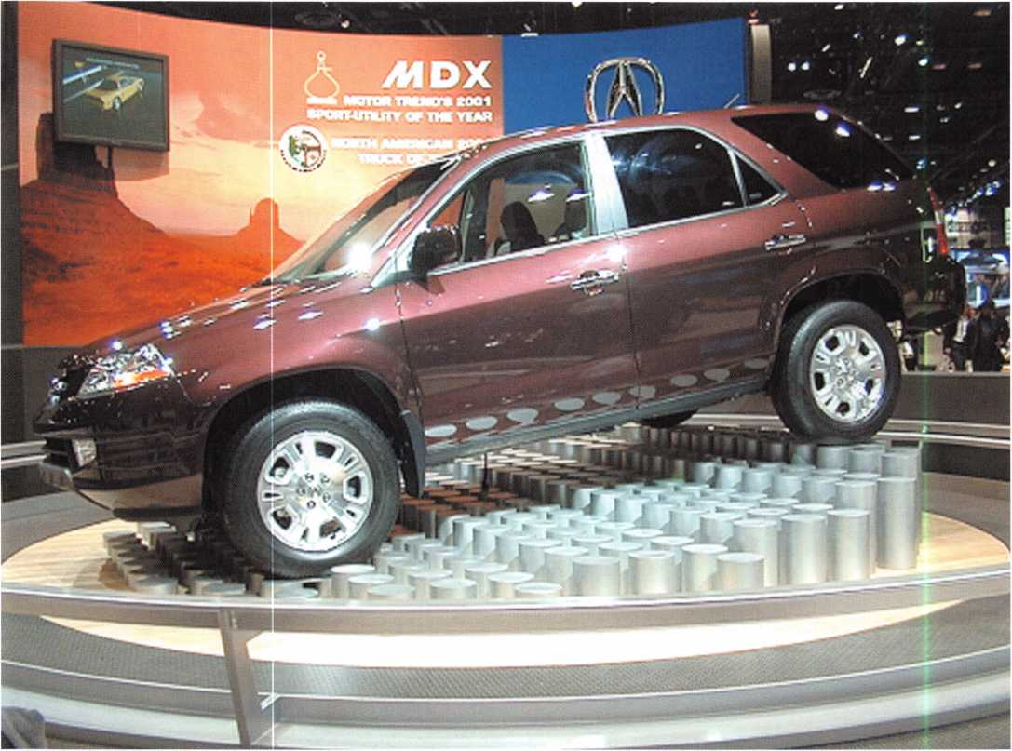

1. The Honda was once one of the easiest import vehicles for which to generate keys. Since the addition of transponders and a high security key sys­tem, the challenges for generating keys has increased.

All About Hondas

By Tom Seroogy

As one of the most common import vehicles locksmiths service, Honda cars rank right near the top. And right up until the introduction of their transponder-equipped models, they were typically the easiest to service (photo i).

From 1990 to 2002, the same key code series (5001-8442) and system were used on all Hondas produced or sold in North America. Starting in 2002, while the 5001-8442 series continued to be employed in most of the Honda models, a new high security key and key code series (K001-N718) was introduced.

Of course, the 1997 introduction of transponders made key generation just a bit more difficult. Originally, pur­chasing the Honda’s original equipment scan tool, the PGM, was the only available solution. On top of pur­chasing a tool that was not only expensive but also difficult to acquire, a four-digit PIN number was (and still is) required. Needless to say, establishing and maintaining a good relationship with the nearest Honda dealer was essential for generating keys on these cars.



Keynotes • February 2004

Fortunately, a couple of aftermarket machines for cre-  
ating and programming keys into the transponder-  
equipped Honda - the SDD manufactured by Ilco,  
and the T-Code offered by Auto Security Products -  
are not available to locksmiths. Both manufacturers  
also offer methods for determining the PIN number  
based on the VIN number of each vehicle. The SDD  
bypasses the PIN number, making the whole PIN  
requirement invisible to the locksmith.

The Keys

While not overly complicated, this new venture into high security is just another sign of the change in automotive key system trends in North America.

The new Honda system is an external four-track system, using six spaces and eight depths (photo 2). Still, as common as this high security key may seem, Honda seemed to go to great lengths to complicate the cutting of the key.

When laid flat, the key includes a left and a right side, each with six spaces for a total of 12, or 24 total cuts, if you include both surfaces of the key. Instead of simply using numbers, Honda has assigned a letter to each of the 12 cuts.

The tip cut on each side of the key has been labeled “X.” If the bitting from the key code is a 1 depth, the “X” position is a 1. If the depth assigned to this posi­tion is 2, the actual depth to be cut is 3.

The fifth cut on the left side is assigned “M/S,” whose depth determines whether the key is a Master or Submaster (valet). If it’s a master key, the depth in this position is a 5 depth; for a valet, the depth of this position is a 2.

To complete their design on confusion, they throw in the “A” space. If the code calls for a 1 depth in this position, the actual cut is a 3. If the code calls for a 2 depth, the actual depth is a 5.

Transponder Systems Since 1997, Honda has introduced four different transponder systems, each appropriately named Type 1, Type 2, Type 3 and Type 4. Following are various

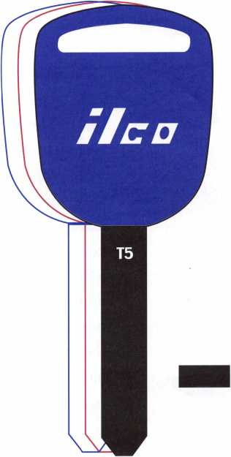

2. The new Honda High Security key blank.

momisM,

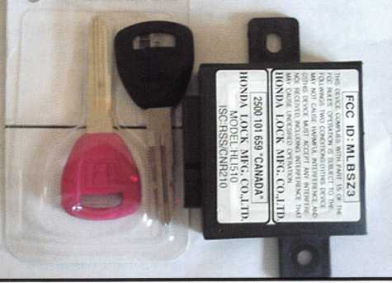

3. The Honda Type 1 system is probably the most difficult Honda system with which to work. Generating new keys requires a new module, a RED program key and an accompanying set of programmed keys.

3

Keynotes • February 2004

**2**

|  |  |
| --- | --- |
| CODE SERIES: | K001- |
|  | N708 |
| SYSTEM TYPE: | Internal  4-Track |
| KEY BLANK: | llco - HO01T5 Silca - HON66 GP |
| STOP: | Tip |

See following slide for description of key code use and tumbler place­ment.

NOTES:

This system uses split wafers. Use caution when picking or impres- sioning.

Honda uses letters to represent the individual spaces of the key. Starting from the bow they are:

Left - E D C B M/S X Right - J H G F A X

Positions J, H G, F, E, D, C, B use depths 1 to 6, and are displayed directly in the bitting of the key code.

The depths shown in the bitting for positions X, A and M/S, however, represent special cuts that are interpreted as follows:

X POSITION

If X is a 1, cut to an actual depth of 1.

If X is a 2, cut to an actual depth of 3.

A POSITION

If A is a 1, cut to an actual depth of 3.

If A is a 2, cut to an actual depth of 5.

M/S POSITION (Master/Sub or Valet Cut)

M (Master) is always a 5 depth.

S (Sub or Valet) is always a 2 depth.

types and what’s needed for key pro- gramming.Type i

1997-2002 Prelude

Of all immobilizer systems, Type 1 cre­ates the greatest challenges for the lock­smith. These vehicles are originally pro­vided with a set of operating keys, plus a RED program key. If either of the oper­ating keys or the RED program key are missing, a new immobilizer module must be installed. As a word of warning: The RED program key is used for program­ming only, and must never be used to try to start the vehicle. Doing so damages the immobilizer, requiring its replace­ment (photo 3).

For those locksmiths already doing (or planning on doing) Toyota/Lexus module programming, the MCP (Multipurpose Chip Programmer) offered by AmericanAutoLock.com also offers the capability of programming the Honda immobilizer on the Type 1 system, elimi­nating the need to purchase a new one. Their link can be found on the web at [www.americanautolock.com](http://www.americanautolock.com), or you can call them toll free at 800/860-5625 (Photo 4).

Spacing & Depths

TIP

|  |  |  |
| --- | --- | --- |
| # | Space | Depth |
| 1 | .724 | .311 |
| 2 | .604 | .297 |
| 3 | .484 | .283 |
| 4 | .364 | .269 |
| 5 | .244 | .254 |
| 6 | .161 | .240 |
| BOW | | |

bilizer, when using the MCP to repro­gram the original immobilizer requires acquiring a pre-programmed RED pro­gram key from AmericanAutoLock.com, This key is designed to match the key data input into the immobilizer, and is easily duplicated using cloneable after- market key blanks and Ilco’s RW2 or Jet’s ETDi (photo 5).

Programming new keys  
for these vehicles  
requires a new module  
with replacement keys  
and a RED program  
key, or an MCP for  
reprogramming the  
original immobilizer, a  
replacement RED pro-  
gram key and an origi-  
nal key blank. Because  
the RED program key  
must match the immo-

Tumbler Placement

|  |  |  |  |  |
| --- | --- | --- | --- | --- |
| TIP | | | | |
| Left | Honda | Space | Honda | Right |
| * | X | 6 | X | * |
| * | M/S | 5 | A | * |
| IDG | B | 4 | F | IDG |
| IDG | C | 3 | G | IDG |
| IDG | D | 2 | H | IDG |
| 1 | E | 1 | J | ID |
| BOW | | | | |

* See notes at left

**28**

Keynotes • February 2004

Type 2 and Type 3

1998-2002 Accords • 2001+ Civic

1998-2000 Odysseys • 2000 Insight 2000 S2000

For all intents and purposes, the key Programming on the Type 2 and Type 3 Honda vehicles is virtually identical, offering only minor variations in the maxi­mum number of programmed keys and other less fre­quently-used key programming functions that are only available using the original equipment PGM scan tool.

Unlike the Type 1 system, a RED program key is not required, and all programming can be completed using a scan tool, a four-digit PIN (not required when using the SDD) and an original key blank.

TyPe 4

2003 Accords

The major difference between Type 4 systems and all the rest is the use of encryption/rolling code technol- ogy to protect the key’s transponder chip from being easily duplicated -- using such tools as Ilco’s RW2 or Jet’s ETDi. As such, Type 4 keys are only available through Honda dealerships.

Aside from this little obstacle, key programming using aftermarket scan tools is identical to Type 2 and Type 3 systems.

Replacement Keys

One of the biggest frustrations with Honda is the absence of factory equivalent aftermarket key blanks. While cloneable keys are available from Ilco and Jet, they cannot be programmed into the Honda vehicle without first being cloned to match an original Honda key. Following are three common methods for pro­ducing or obtaining a good key:

1. Don't forget the obvious: Purchase factory originals from a Honda dealer. Because the Type 4 encrypted/rolling code key blank cannot be cloned or replicated, this is the locksmith's only option for vehicles on this immobilizer type.
2. Use cloneable aftermarket key blanks and clone a factory original that is kept for programming reasons only. The disadvantage to this method is that all keys produced using this method will have the same transponder code.
3. Ilco's RW2 with v.23 or higher software allows the locksmith to repli­cate a factory original transponder key blank using a cloneable aftermarket Honda key.
4. The MCP by AmericanAutoLock.com allows the locksmith to program Type 1 Honda immobilizers as well as early Toyota and Lexus ECMs.

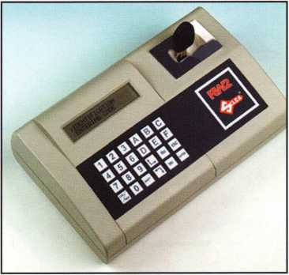

1. Ilco's RW2 and Jet's ETDI can be used to clone existing Honda transponder keys. The RW2 offers the advantage of being able to use cloneable keys to replicate Honda original transponder keys without the need for an existing key

About the Author: Tom Seroogy is a 20-year locksmith specializing in automotive and access control. He is co-author of "The National Locksmith Guide to Basic Master Keying ," "Saber Tool Company's Guide to Ford Transponder Systems/' "The National Locksmith's Guide to GM Steering Column Service/' as well as BWD's manual series on GM VATS service. Seroogy is the founding editor of The National Locksmith Automobile Association and has been a contributing author to Keynotes, The National Locksmith and Locksmith Ledger. He is author of numerous articles on general locksmithing, access control, basic electronics, general automotive, high-security automotive, keyless remotes, automotive diag­nostic tools and techniques, and transponders. Seroogy is an ALOA ACE certified instructor and has taught various locksmith related courses around the country. Seroogy has served on the sales and product development teams with STRATTEC, BWD (formerly All Lock), and, most recently Lockmasters. He is the founder, developer and former director of Lockmasters' PUREAuto Automotive training program. Seroogy is currently pursuing a career in forensic/investigative automotive locksmithing. You can contact Seroogy at [tgseroogy@hotmail.com](mailto:tgseroogy@hotmail.com).

Keynotes • February 2004

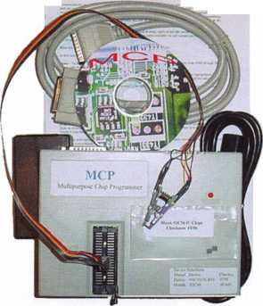

Safe Servicing and  
Combination Changing, Part 2

By Jim Hancock, CRL

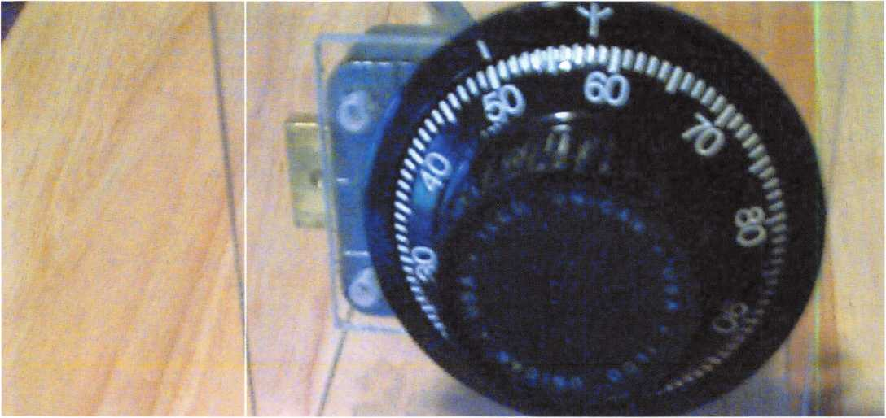

Handle Cam, Boltwork, External Relockers and...the Lock

Depending upon the type of safe you are working on, your approach to the next step may differ somewhat; but your bottom line will be the same. If you are dealing with an in-the-floor safe, in which the back cover actually retains the relocker, you would need to examine the cover carefully for abuse, and also any detent pin that holds the relocker in place. A good portion of problems that occur in these in-the-floor safes are created by the “dive bomber theory” of closing the safe. Instead of leaning down and placing the head in the tube, they gener­ally get within a few inches (feet?) of the opening and drop the safe head in hopes of getting it to the hole. If you are working on a stand-up floor model, this will hopefully not be a problem. Hopefully.

On an upright floor safe, once the back cover has been removed from the door, first examine the boltwork. Does it move smoothly within the guides when turning the handle? Is it connected securely to the handle cam? Are there any physical material breakdowns? If all the above questions receive a positive response, then exam­ine the handle cam itself, making certain that it is attached securely to the handle spindle. Some cam types are held on by threaded stanchion and nut, while others may be held in by roll pins or cotter pins. In either case, make certain the mounting is secure and in no danger of coming off. Another of the many problematic open­ings you will encounter is the handle and cam becoming separated.

Keynotes • February 2004

After checking the boltwork and cam assembly, direct your attention to any relocking devices. There are many different setups on relockers, but they all serve the same purpose -- to protect the contents of the safe from forced entry by “deadlocking” the boltwork, should violent entry be attempted. The most common relocking system will involve a spring-loaded bolt, which, when released, will fire into a cutaway or hole in the actual boltwork, thereby locking it completely from movement, even with the known combination. This type of relocker is usually held in the neutral or open position by means of an extension bar attached to the back cover of the lock. In servicing the safe, check the extension to make certain that it contacts the relocker solidly and is in good physical condition. Also, check the spring tension on the relocker bolt itself to make certain it is in good working order.

Many safe technicians neglect to check this area, which is a great disservice to the customer, since the relocker provides such an added security advantage.

On the higher end of the spectrum, there is a device called a glass relocker. This is generally found in the higher security containers, and is exactly what it sounds like. It is a sheet of tempered glass that will vary in size and thickness, depending upon the manu­facturer. It is mounted to the inner skin of the door and will be situated so as to protect the lock body as well as the handle cam, in most cases. Attached to the glass will be fine-stranded wire bands, which are tied to spring-loaded or gravity “deadbolts.” The purpose of this relocker, when forced entry is attempted, the glass will break, allowing the deadbolts to release and either lock the boltwork, or in some cases, the dead­bolts will actually inject into a cavity in the door frame. In any case, the safe door is effectively locked, and can’t be opened by normal means, even with the proper combination. Because of the severity of this relocking method, it is indeed beneficial to inspect the glass relocker system to verify its condition. First, inspect the glass itself, making certain that the glass is in good condition, showing no edge cracks or deformi­

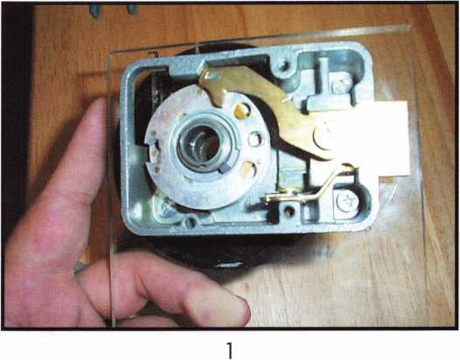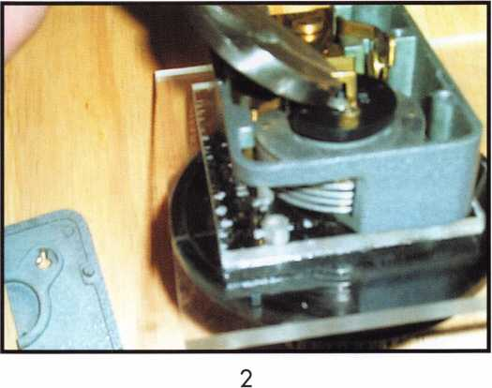

ties around the mounting hubs or wire attachments. These deformities could easily cause the glass to shat­ter by just letting the door slam too hard. Next, inspect the wire bands at both ends of attachment as well as the length of strand for wear and ragged edg­ing. Again, wire fatigue can cause a false firing of the relocking mechanism, causing a lockout. Last, check the deadbolts themselves, making certain they are in good condition, with no deformities and having good spring tension against them. Also be aware that some manufacturers will use gravity-fed bolts as opposed to spring-driven bolts. Don’t be concerned if there is not a spring!

Keynotes • February 2004

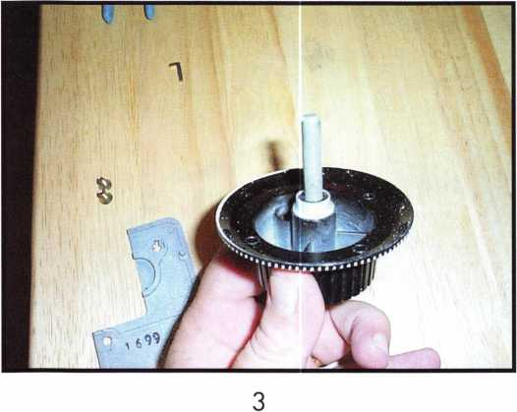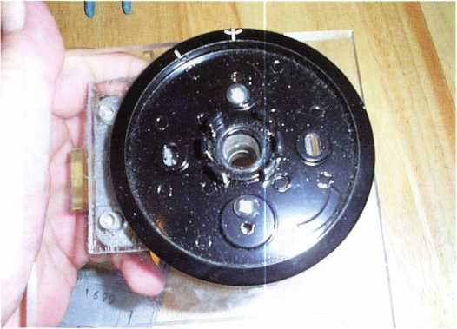

Once finished with this inspection, turn your atten­tion to the lock itself. The first thing to look at is the back cover of the box itself Since a large part of relocking devices are activated by the rear cover, veri­fy that the relock trigger is attached firmly to the cover. This is usually accomplished with either the screws that hold the cover on, or by a rivet through the cover. The other reason to examine this back cover is to ascertain the brand of lock, which will be useful information later in the process. Once the relock trigger has been examined, remove the cover and look at the inside surface of the cover for wear patterns. If there is a heavy line of wear on the cover,

you possibly have a problem with the drive cam rub­bing against the cover, which could indicate that the cam is not seated correctly, the cover is bent, the spindle is warped, etc.

When you have completed this step, lay the cover aside and look into the lock body itself (photo i). As with any mechanical device where moving parts con­tact each other, there will be a certain amount of loose debris allowable in the cavity. But, not unlike an automobile transmission, too much debris usually indicates a serious problem in the making. Next, care­fully remove the spline key from the drive cam (photo 2), and make certain it is in good condition and fits snugly into the spline of the spindle. Carefully unscrew the drive cam by holding it securely and turning the dial counter-clockwise until the dial pulls out. At this point, you can examine the underside of the dial (photo 3) and dial ring (photo 4) for wear, and verify the existence of a bushing in the dial ring. With the drive cam in hand, turn it over and examine the drive pin (photo 5). This little pin is one of the most crucial parts of the locking mechanism, for without it, the lock will not function. A good portion of these pins are pressed into the drive cam after the cam is manufactured; therefore, it is not unheard of that these pins will become loose, and eventually fall out. Verify that the pin is firmly attached to the drive cam, and that the pin doesn’t have any inordinate wear around it. Once finished, remove the four mounting screws that hold the lock body on the door.

With the lock in hand, remove the bolt screw, which holds the lever assembly. Carefully uncoil the return spring by lifting up the lever and rotating counter­clockwise until you can remove the assembly.

Examine the lever and fence for wear patterns (photo 6). You might see some scoring caused by the wheels against the fence; however, there should not be any grooves in the metal. Once this is completed, you’ll next want to verify that the internal relock trigger (the brass pivot attached to the box) is in working order. It should pivot freely, and should be reasonably

Keynotes • February 2004

tight in the box. The leading edge of the brass pivot should fit snuggly into the notch in the bolt. Now slide the bolt out of the lock housing (photo 7) . Underneath the bolt, you will find a small ball bear­ing, which is spring-loaded to put tension against the bolt. On the underside of the bolt, you will see a detent that acts as a seat for the ball bearing. The purpose of this bearing is to act as a positioner for the bolt. With the bolt fully extended, the bearing holds the bolt snuggly in place. Without this bearing, the amount of play in the bolt increases, causing prob­lems later.

Now you should remove the Spiralox washer that holds the wheel pack to the wheel hub (photo 8). This is a bit tricky; you do not want to get this spiral dis- proportioned because it won’t hold the correct ten­sion on the wheels. Close inspection will show a small notch in the leading edge of the spiral. With a little practice, you can raise this edge with a broken pick (or similar tool) and uncoil the washer. Once this washer is removed, lift the first wheel that you see out of the body. In safeman lingo, this is the third wheel - - or the third number in your combination. The third wheel will always be the wheel closest to the drive cam. Gently turn the wheel over and you should have two items fall from the inner hub (photo 9). One will be a spacer, the other will be the fly. This should be true of all three wheels as you remove them. I stress “should,” only because you will have your uneducated safe technician wannabes who will either remove the spacers as a way of adjusting tension to the wheel pack. Or, even worse, they will use more than one spacer on one wheel to accomplish the same thing, or to compensate for a problem with the wheel, fly or drive pin that they could not diagnose. These spacers serve a critical function in that they restrict the drag of wheel on wheel. Without this, it is possible that moving one wheel will drag another with it. The other item that falls out is the fly. This small, usually brass, almost insignificant looking piece of metal is actually one of the major keys to cracking a safe. Remember the drive pin on the back of the drive

5

6

cam? This fly is the part that contacts the drive pin and allows the wheel to move. If the fly is not moving freely within the wheel track, or if you do not put the fly back in correctly, you can be assured that the safe lock will not open correctly, if at all.

With all the components now removed from the housing, what you are left with should be a tensioning adjuster. By moving this ratcheted adjustment left or right, you can loosen or tighten the amount of tension against the wheel pack. This adjustment can be made with the wheel pack in place, thereby removing most of the guesswork as to proper adjustment. In older locks, prior to these adjusters being used, the tension

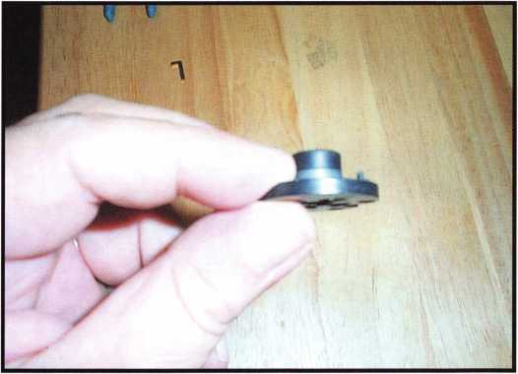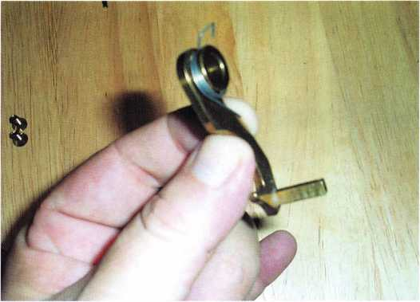

Keynotes • February 2004

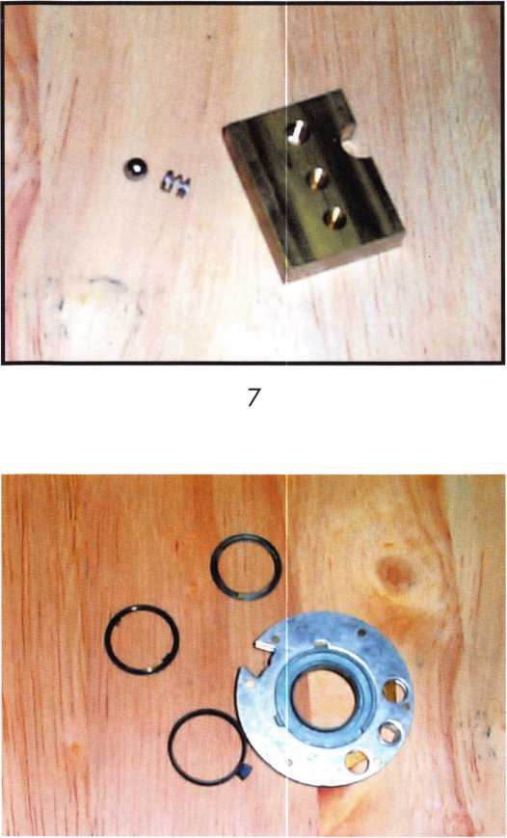

8

was maintained with a large washer, spring-formed to hold upward pressure. This was the standard for years, but as with any piece of spring material, after a period of use, the material lost its spring property and the wheel pack would get loose and create a very slop­py operation.

Lock Re-Assembly

It is now time, after all the parts have been examined, to start re-assembly of the lock. It is during this process that we will lubricate the lock. The choice of lubricant is critical in that a product that is too

“heavy” will not allow the wheels and flies to move freely, and can cause the parts to bond together. A lubricant that is too “light” will not allow for long­term lubrication, meaning another trip to the safe because it becomes harder to open. You don’t want to have the metal components grinding against each other. I realize that most locksmiths swear by WD- 40, Tri-Flow or some other miracle juice that we use to lubricate locks and various parts. These have no place in safe lubrication. Most of these products leave a film as they evaporate. With the introduction of any foreign matter, such as fragments of metal or plastic from the moving lock parts, this film will tend to become an adhesive and bind the parts. It is accept­able to use one of these products to clean the compo­nents, provided you completely dry the parts when done.

What I use as a lubricant is generally a lithium or Teflon-based grease. Squeeze a small dollop on your forefinger and rub together with your thumb. The residue left over is all that is required to lubricate the parts. As you re-assemble the safe, the grease residue that is left by simply touching the parts will leave enough lubrication to allow the safe to operate. There are specific lubrication points recommended by the lock manufacturers, which you should learn and use.

After all the components are re-assembled -- the wheels on the post, the flies on the wheel hubs, the spirolex washer in place — you should now verify that the parts are all moving well and in correct timing with each other. You can accomplish this by inserting the drive cam into the post and using your fingers to rotate the cam. As you rotate the cam 360 degrees, the third wheel (remember this is the wheel nearest the cam) should then begin to turn. Another 360 degree rotation will then begin to move the second wheel. A final rotation should begin to move the first wheel. With each successive rotation, you should feel the flies contact and see the wheels move without any real change in the amount of drag against your turn­ing pressure. If there are any problems with this



Keynotes • February 2004

process, the lock will need to be disassembled and examined to determine the problem.

Assuming that everything works well at this point, you now should feel confident that the safe lock is in good working order. Now, you’re ready to change the combination, which is what well cover in the third and final installment of this series. See you next month.

About the author: Jim HancockCRL, began his locksmithing career at the age of 8 in his grandfathers lock shop in Gulfport, Mississippi. He has been working as a locksmith since 1974. He currently is the manager of Cothron 's Lock & Safe and the lead instructor of Cothron 's School of Professional Locksmithing in Austin, Texas. Jim has taught for many regional associations and is an ALOA Certified Instructor who teaches at ALOA conventions and at ACE classes throughout the country.

**THE HINGE DOCTOR**

**by GKL Products**

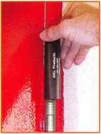

**HA1 For  
Standard**

**Commercial**

**4-1/2" x 4-1/2'**

**Butt Hinges**

**HA2**

***"The HULK***

**For Residential Hi**

COMING IN  
SEPTEMBER

**HA3  
For Bail**

**Bearing &**

**Commercial Hinges**

**The Hinge Doctor is a great way to repair those sagging metal  
doors. Slip the tool over the hinge and open the door an inch**

**or two past the point where the tool binds against the**

**hinge, remove the tool and check the door,**

**which should now be working properly.**

**If you're a locksmith these tools  
will turn a profit the 1st time you  
use them!  
Uses - schools, hospitals,**

**commercial buildings, storefronts  
with butt hinges, office doors, new**

**construction, door alignment, sagging**

**doors, jail cells, anywhere there are  
commercial grade hinges.**

**HA4**

**For Prison**

**& Institutional**

**Hinges &**

**Spring Hinges**

Over

**10,000**

Satisfied

Customers

US Patent **#6450003**

**[www.hingedoctor.com](http://www.hingedoctor.com)**

800-924-5397

Keynotes • February 2004

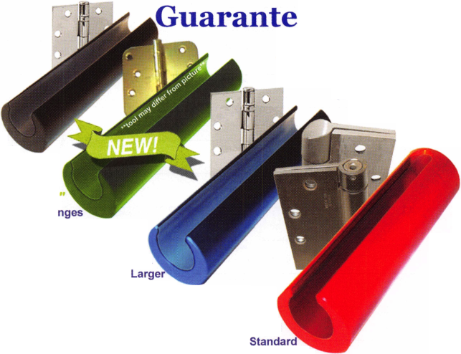

BOARD

**nominations**

**What ALOA Board Positions Are Open and Where Am I Qualified to Run?**

There are currently seven regional directors positions open for election in addition to the position of Secretary. ALOA members now elect the directors from their own regions. Only ALOA members from a region are eligible to run for the open posi- tion(s) in that region. And only mem­bers from the nominee's regionwill receive a ballot to vote for that can­didate. Members from any region are eligible to run for the Secretary position. You must have been an ALOA member for at least three years to run.

The following vacancies will exist for the election to be held before the ALOA 2004 Convention.

**Northeast three directors**

**South Central one director**

**Northwest one director**

**Asian one director**

**European one director**

**Secretary**

If you have any questions, please contact Charles Gibson at (800) 532-2562 or email [charlie@aloa.org](mailto:charlie@aloa.org).

On this page you will find the required nomination petition and on the following page, the nomination form.

The following is the number of signatures required for each Board position:

**Secretary 25**

**Northeast 22**

**South Central 7**

**Northwest 4**

**Asian 3**

**European 4**

Associated Locksmiths of America, Inc.

Board of Directors Nomination Petition

Please print legibly or type. This form can be reproduced if needed.

I, the undersigned, request that be placed on

(name of nominee and member number)

the ballot for for the election to be held at

(position for which individual is being nominated)

the special meeting of ALOA members to be held in 2004 or any adjournment thereof. I am eligible to vote in the region.



PRINTED NAME



PRINTED NAME



PRINTED NAME



PRINTED NAME



PRINTED NAME



PRINTED NAME



PRINTED NAME



PRINTED NAME



PRINTED NAME



PRINTED NAME

11

PRINTED NAME

12

PRINTED NAME



PRINTED NAME



PRINTED NAME



PRINTED NAME



PRINTED NAME



PRINTED NAME



PRINTED NAME



PRINTED NAME



PRINTED NAME

21

PRINTED NAME

22

PRINTED NAME



PRINTED NAME



PRINTED NAME



MEMBER #

MEMBER #

MEMBER #

MEMBER #

MEMBER #

MEMBER #

MEMBER #

MEMBER #

MEMBER #

MEMBER #

MEMBER #

MEMBER #

MEMBER #

MEMBER #

MEMBER #

MEMBER #

MEMBER #

MEMBER #

MEMBER #

MEMBER #

MEMBER #

MEMBER #

MEMBER #

MEMBER #

SIGNATURE

SIGNATURE

SIGNATURE

SIGNATURE

SIGNATURE

SIGNATURE

SIGNATURE

SIGNATURE

SIGNATURE

SIGNATURE

SIGNATURE

SIGNATURE

SIGNATURE

SIGNATURE

SIGNATURE

SIGNATURE

SIGNATURE

SIGNATURE

SIGNATURE

SIGNATURE

SIGNATURE

SIGNATURE

SIGNATURE

SIGNATURE

PRINTED NAME

MEMBER #

SIGNATURE

YOUR COMMITMENT TO ALOA BOARD SERVICE

(Please read carefully and sign where indicated.)

The responsibilities of an ALOA board member include contributing a moderate amount of personal time, and a significant degree of professional guidance and expertise to the organization.

You will be expected to come to board meetings and the annual membership meeting. You will need to be prepared to sensibly discuss matters of great importance to your profession and participate in setting policy as part of a governing body. Your course of action during your tenure on the ALOA board should be guided by fair minded, constructive goals pertaining to matters of consequence for ALOA and for the industry. Your contributions are expected to benefit ALOA as a whole, taking individual member rights and concerns into account, but free of the taint of partisan politics or personal gain.

On a practical note: ALOA board members are expected to behave and dress professionally at all times, especially when actively representing the association. ALOA board members are required to participate in two board meetings per year, of three or four days in length, one each fall and spring. Board members are also asked to attend the annual con­vention and are required to attend the annual membership meeting. Board members may also be asked on a voluntary basis, to represent ALOA at related local, state or regional functions, including serving in the ALOA Booth and otherwise promoting ALOA. When travel is required for a board member, expenses covered by ALOA include lodging, travel and a reasonable per **diem.** The Board has stipulated that assigned travel will be reimbursed at the lesser of the 30-day advance tourist class airfare in effect at the time of travel or the current per-mile rate for travel by personal automobile. Spouse expenses, including extra room charges, etc., are the individual's responsibility.

• • •

I have read and understand the above responsibilities of an ALOA board member, and agree to commit my time and energies as needed. I certify all of the information contained on this form and supporting documentation to be true and complete.

I can be contacted with questions at:

Address Phone #

Signed:

Date

Please attach a recent photograph of yourself and retain a copy of this profile for your own files. This profile and all supporting documentation should be submitted no later than March 1, 2004:

Mail to:

Nominee Profile

Secretary of the Board of Directors  
Associated Locksmiths of America, Inc.

3003 Live Oak Street  
Dallas, TX 75204-6186  
1-800-532-2562

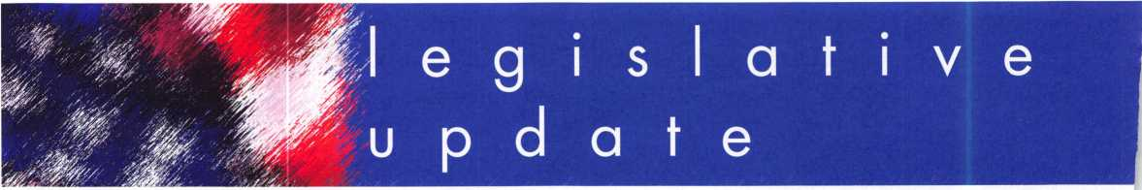

ASSOCIATION HEALTH PLAN LEGISLATION GAINING MOMENTUM!

With the House and Senate both reconvening recently for the second session of the 108th Congress, it is expected that the Association Health Plan legislation will receive renewed attention in the Senate in the coming weeks and months. The primary focus continues to be the Senate Republican Uninsured Task Force chaired by Senator Judd Gregg (R-NH). There have been minimal discussions at the staff level regarding the issues under consideration by the Task Force since Congress adjourned in mid- December. However, it is expected that the Task Force will resume deliberations in earnest very soon, and the AHP legislation will be actively considered in this process.

In January 20th's State of the Union Address, President Bush called on the Congress (the Senate) to enact AHP legislation.

"...On the critical issue of health care, our goal is to ensure that Americans can choose and afford private health care coverage that best fits their individual needs. To make insurance more affordable, Congress must act to address rapid­ly rising health care costs. Small businesses should be able to band together and negotiate for lower insurance rates, so they can cover more workers with health insurance - I urge you to pass Association Health Plans..."

The next morning, Senator Frist mentioned AHPs as one of the solutions to rising health care costs on the Today Show. Things are going very well indeed!

SUPREME COURT LETS STAND RULING ON JUNK FAXES:

The Supreme Court on Jan. 1 2 let stand an appeals court ruling upholding the ban on junk faxes that was implemented in 1991 as part of the federal Telephone Consumer Protection Act. The case arose in Missouri where the state Attorney General's office sued California-based Fax.com, whose lawyers then challenged the constitutionality of the law. The Supreme Court's refusal to consider the case ends the appeals process in the case. The Federal Communications Commission (FCC) hit Fax.com earlier this month with the largest fine ever for violations of the TCPA - nearly $5.4 million, for violations on 489 separate occasions.

PRESIDENT SIGNS ANTI-SPAM BILL:

WASHINGTON - President Bush signed the "Can-Spam" bill Tuesday, creating the first federal law regulating spam, a move backers say will be a major step in the war against e-mail solicitations for pornography, Viagra, diet pills, get-rich-quick schemes and the like.

But critics scoff that e-mail users will be unlikely to see a decline in the volume of junk in their in-boxes as a result of the Controlling the Assault of Non-Solicited Pornography and Marketing Act, which would kick in on New Year's Day.

Keynotes • February 2004

Congress overwhelmingly approved the legislation ear­lier this month, after more than six years of unsuccessful attempts to enact a law to interrupt the flood of com­mercial e-mail.

With Bush's signature, a complex set of rules will take effect Jan. 1 to govern how companies may communi­cate with customers they already know and with people they don't. Falsified e-mail headers could be punished with prison terms, as could sending "sexually oriented" e-mail that is not properly labeled. The Federal Trade Commission receives new enforcement authority and could choose to set up a "do not e-mail" list akin to the commission's wildly popular National Do Not Call registry.

Web portal and e-mail giant Yahoo was quick to hail the bill's enactment.

"This legislation is a victory for consumers and the Internet," Yahoo said in a statement. "It provides busi­nesses with important new legal weapons in the ongo­ing battle against spam. And it supplements the current technological, educational and legal tools Yahoo and others are using to fight this threat," the company said.

But the law has raised alarm among some spam fight­ers because it would legalize sending nonfraudulent spam and zap state laws that in some cases prohibit that practice. At least 34 states have slapped regula­tions on bulk e-mail, with some jurisdictions going much farther than Washington, D.C. Washington state has granted e-mail recipients the right to sue spammers, and California and Delaware have mandated an "opt­in'1 approach that prohibits unsolicited commercial e- mail without a prior business relationship.

Unlike the California and Delaware laws, Can-Spam sets an "opt-out" standard, and it denies individuals the right to sue spammers. California Sen. Debra Bowen, a Democrat who supported her state's legislation, said in a statement on Dec. 8 that Can-Spam "doesn't can spam, it gives it the congressional seal of approval ... An advertiser's First Amendment right to free speech doesn't trump a person's basic right to be left alone. Spam isn't legitimate advertising and it's not free speech."

Bush's signature comes as the flow of solicitations from bogus confidants of deposed Nigerian dictators has reached an all-time high, bedeviling corporate America and driving individual PC users to distraction. E-mail security company MessageLabs said last week that spam increased dramatically in 2003, with a 77 per­cent increase over last year. In May, spam accounted for more than 50 percent of all business e-mail traffic, and it now represents about two-thirds, MessageLabs said.

Everett-Church and other spam opponents have said that because Can-Spam will legalize nonfraudulent spam, every business in the United States could send an unspecified amount of unsolicited e-mail repeatedly, until the recipient asks to be removed. The Small Business Administration says there are 22.9 million small businesses in the country, and each one would be able to take advantage of this new legal right.

It's also unclear what effect any U.S. law can have internationally, something that Congress appears to be slowly recognizing. Two U.S. senators and three U.K. members of Parliament endorsed close "cross-border" cooperation between the two countries in a joint letter on Dec. 8. The agenda of a United Nations summit that began Dec. 10 in Geneva urges governments to "take appropriate action on spam at national and internation­al levels," and an Organization for Economic Cooperation and Development summit is scheduled for Brussels in February.

Perhaps that explains why, even before Bush signed Can-Spam into law, some U.S. politicians are already talking about what to do next. Rep. John Dingell, D- Mich., predicted in November that "it is quite possible that we will have to revisit this matter again."



Keynotes • February 2004

Classifieds



EMPLOYMENT

FKI SECURITY GROUP SEEKS QUALIFIED TECHNICIANS FOR NEW FIELD SERVICE DIVISION

In response to continuing and growing demand for field service, FKI Security Group has estab­lished the FKI Field Services division to support NKL Cash Handling products and is seeking qualified technicians in major metro markets. Technicians will support business development and new service contracts for NKL Cash Handling, which include electronic bill-counters or validators, dispensing safes and access con­trol safes. Each field technician will be equipped with a state of the art communications system and all the necessary parts and tools to service all of FKIis security products.

The markets currently open are, Baltimore/ Washington DC, New Jersey/Metro New York, North/Central Ohio, Dallas, Houston, Orlando/ Central Florida, Northern California, Sacramento/ East Bay, Southern California, Phoenix

Highly competitive compensation and a com­plete benefits package including health, dental, and vision insurance, 401 K plan, and fully paid expenses will be offered to qualified technicians. Technicians with the experience servicing safes, locks, ATMs or POS systems will be considered. This position can grow into a management position as the division expands.

Interested parties should contact Christina Lyell at 800-457-2424 or e-mail your resume to [chrisl@fkisecuritygroup.com](mailto:chrisl@fkisecuritygroup.com)"

FKia

SECURITY GROUP

101 Security Parkway • New Albany, IN 47150

PROFESSIONAL EXPERIENCED TECHNICIAN(S) WANTED:

We are in need of 1 to 2 technicians with the ability to Sell, Install, and Service all major mfg. Hardware. We are located in Knoxville, Tennessee and service all areas of east and mid­dle Tennessee. Must have a clean criminal and driving record. Must have professional attitude and appearance. Background check and References must be supplied. Must be experi­enced in commercial, industrial, and residential hardware sales, service and installations.

Access and other areas is a plus.

Paid Holidays, Retirement, Health insurance, uniforms, tools and truck supplied. 8-5pm Monday thru Friday.

Ph# 800-484-5577, pin 0841 Fax# 865-637-2359 E-Mail: [info@fmgeorge.com](mailto:info@fmgeorge.com)

LIVE AND WORK IN PARADISE!

A 20-year-old mobile business that has not yet peaked - owner retiring. Located in beautiful Lake Arrowhead, CA. State-of-the-art 2003 GMC AWD 2500 Savannah Van. ITL950C computerized code key machine. Rytan RY100 high-speed key machine. Office furniture, note­book, computer and equipment. Commercial and residential accounts. Can also include 3BR/3BA lake view home. Serious inquiries only, please. I AM NOT PARTING THIS OUT. 909/337-8254 cell 909/295-3310

JOIN OUR PROUD TEAM!

The Broward County Sheriff's Office Is Hiring in Sunny South Florida!

Besides our location in paradise, South Florida is a mecca of culture, beautiful beaches, and recreational advantages. Join our 5,000-member team, America's largest nationally accredited Sheriff's department, and enjoy the excitement and benefits of South Florida living including No State Income Tax!

MAINTENANCE SPECIALIST (Locksmith)

$29,731 - $43,926

In this position, you will perform a wide variety of locksmith and general trade related duties in a detention facility environment. This may include installation, maintenance and repair work involving highly sophisticated state-of-the- art systems designed to support effective and efficient corrections operations. Qualifications include a high school diploma or equivalent (GED), three years experience and/or training in locksmith work, a valid Florida's driver's license.

Department of Motor Vehicles certified seven (7) year driving history dated within one month of application date required with application. If you're qualified and interested in building a great career in South Florida, please contact us at 888-BSO-STAR or visit [www.sheriff.org](http://www.sheriff.org). EOE M/F/D/V DFWP

BSO is an equal opportunity employer and does not discriminate based on age, citizenship sta­tus, color, disability, marital status, national ori­gin, race, religion, sex, or sexual orientation. Veterans' preference per Florida law.

Classified Advertising Policy

Classified advertising space is provided free of charge to ALOA members, and for a fee of $.60 per word, $15 minimum for non-members. Classified ads may be used  
to advertise used merchandise and overstocked items for sale, "wanted to buy" items, business opportunities, employment opportunities/positions wanted and the like.  
Members or non-members wishing to advertise services or new merchandise for sale may purchase a "Commercial Classified Ad," for a fee of $1.30 per word, with a  
minimum of $40. Each ad will run for two issues. For blind boxes there is a $5 charge to members and non-members. All ads must be submitted in writing to the ALOA  
office by the fifteenth of the month, two months prior to issue date. Send to Keynotes Classifieds, 3003 Live Oak St., Dallas TX 75204-6186. ALOA reserves the right to  
refuse any classified advertisement that it deems inappropriate according to the stated purpose of the classified advertising section.

STOP LOOKING!!

EXPERIENCED TECHNICIANS WANTED Lock into your future now! If you are experienced, intelligent, and desire a secure future, come join our team. We are a full service commercial/residential security service (locks, keys, safes, CCTV, access control, door-related hardware). We offer top wages, company vehicle, 401k, paid vacation, paid holidays, new uniforms, cross training, and job satisfac­tion. We are looking for the best techs, who are ready to be treated and com­pensated as professionals.

Bass Security Services, Inc. 216-755-1200, XI28 Fax 216-755-1220 e-mail: [rmesnick@bass-security.com](mailto:rmesnick@bass-security.com)

WANTED TO BUY/SELL

FOR SALE

Original Schlage blanks in 5-pin EF keyway or 6-pin in CE, EF, FG or G keyway at $ 12.50 per box of 50. Contact George Thomas at 218-724-3416 or write to 825 Woodlandd Ave., Duluth MN 55812-2168

WHOLESALE SAFE DEPOSIT LOCKS

Allied, Diebold, Herrin, Hall & Mavin, llco, Lefabure, Mosler, Precission, S&G, Security Corp., Yale. Locks from early 1900s to current. Call or email for lock type and pricing sheet. Quantity discounts. Call WBI at (954)484- 2404 or email: [sales@wbi.us](mailto:sales@wbi.us)

FOR SALE

Owner retired. Framon Model 2 w/ manual and Scotsman Model 747XU w/ manual.

Like new. Reed code books 1, 2, 3, 4 and 5. Call 919/676-8490.

WANTED TO BUY

Automotive transponder equipment wanted. Triax machine, T-Code, TCL, EDT Jr., RW2,

A-l Pack-a-Punch. Call 877/411-5397 and ask for Bob.

BUSINESS FOR SALE

BUSINESS FOR SALE

A small, quite successful business for sale in south Orange County, California. Three Rytan machines, three HPC code machines, HPC code books, coding program, tools for "luxu­ry" vehicle lockouts - all parts, tools and sup­plies to keep two trucks on the road full time. One truck on the road provides $10-1 IK per month. Truck, which is the Ford F250 van with advertising signage, built-in work areas and cabinetry - can be part of the package or pur­chased separately. Low operating costs after 10 years of building the business. Advertising expenses 10 years ago? $4K per month. Now we pay a fifth of that. This is a nice set-up for someone to step in and take over. Existing accounts (which bring in about $8200/month include three in property management and eight auto dealerships. Well work to set you up with our existing accounts.

All reasonable offers will be considered.

Call 949/370-9619, or fax 949/458-1733.

MOBILE LOCKSMITH BUSINESS FOR SALE

Speedex duplicator, van, tools, code books, two HPC code machines (Blitz), inventory, some hardware. $6000 (firm).

Call 601/916-6448.

LOCKSMITH FRANCHISE AVAILABLE

Low cost, complete training, national Franchise call (925) 260-7373 • [www.SpeedyLocksmiths.com](http://www.SpeedyLocksmiths.com) .

CENTRAL OREGON COAST

Well-established Lock Shop with 50 -mille AAA Contract, 24-hour Mobile Van Service, Commercial, Residential and Turn-Key Auto Shop. No pun intended! Owners will train and/or assist with the transition of this busy shop with a great location on Highway 101 in the heart of Coos Bay. Cash or contract terms. Call Realty Solutions LLC • Ellie Cairy 503- 620-5533

Advertise with Weatherproof Safety Labels!

Lockout your  
competition

by placing your  
calling card on  
every door you  
service! Keep

your name in front  
of every customer  
with these Durable,  
Affordable Labels  
Call & Order Today  
1-800-355-6322

(Actual Label Size 1 1/2x4 1/2)

Professional Business Products

ALOA Associate Member

Check out our competitive prices on Invoices with two color ALOA  
logo, Repair Tags/Claim Checks, Business Cards, Door Hangers,  
Shirts, Hats, Pens, Key Tags, Magnets.

[www.professionalbusmessproducts.com](http://www.professionalbusmessproducts.com)

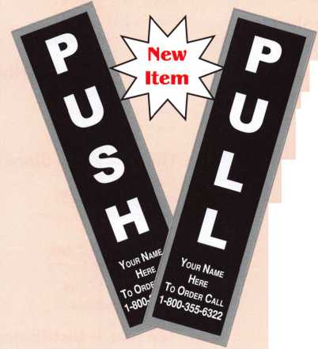

**associate**

**members**

Distributor

**Ace Lock & Security Supply**

Phone: 800-223-5625 Fax: 908-688-2442 [www.acelock.com](http://www.acelock.com)

**Andrews Wholesale Lock Supply**

Phone: 717-272-7422 Fax: 717-274-8659 [www.andrewslock.com](http://www.andrewslock.com)

**Boyle & Chase Inc**

Phone: 800-325-2530 Fax: 800-205-3500 [www.boyleandchase.com](http://www.boyleandchase.com)

**Clark Security Products**

Phone: 800-854-2088 Fax: 619-974-5284 [www.clarksecurity.com](http://www.clarksecurity.com)

**Cook's Building Specialties**

Phone: 505-883-5701 Fax: 505-883-5704

**Direct Security Supply, Inc.**

Phone: 800-252-5757 Fax: 800-452-8600

**Doyle Security Products**

Phone: 800-333-6953 Fax: 612-521-0166 [www.doylesecurity.com](http://www.doylesecurity.com)

**Dugmore and Duncan, Inc.**

Phone: 888-384-6673 Fax: 888-329-3846

**E. L. Reinhardt Co., Inc.**

Phone: 800-328-1311 Fax: 651-481-0166 [www.elreinhardt.com](http://www.elreinhardt.com)

**Fairway Supply, Inc.**

Phone: 214-350-0021 Fax: 214-352-4299 [www.fairwaysupply.com](http://www.fairwaysupply.com)

**Foley-Belsaw Company**

Phone: 800-821-3452 Fax: 816-483-5010 [www.foley-belsaw.com](http://www.foley-belsaw.com)

**Fried Brothers Inc.**

Phone: 800-523-2924 Fax: 215-592-1255 [www.fbisecurity.com](http://www.fbisecurity.com)

**Hardware Agencies, Ltd.**

Phone: 416-462-1921 [www.hardwareagencies.com](http://www.hardwareagencies.com)

**IDN Incorporated**

Phone: 817-421-5470 Fax: 817-421-5468 [www.idn-inc.com](http://www.idn-inc.com)

**Jo Van Distributors**

Phone: 416-752-2238 Fax: 416-752-7282 [www.jovanlock.com](http://www.jovanlock.com)

**Omaha Wholesale Hardware**

Phone: 800-238-4566 Fax: 402-444-1664 [www.omahawh.com](http://www.omahawh.com)

**Security House**

Phone: 905-669-5300 Fax: 905-660-6313 [www.securityhouselock.com](http://www.securityhouselock.com)

**Security Lock Distributors**

Phone: 800-847-5625 Fax: 800-878-6400 [www.securadealer.com](http://www.securadealer.com)

**The Locksmith Store Inc.**

Phone: 847-364-5111 Fax: 847-364-5125 [www.locksmithstore.com](http://www.locksmithstore.com)

**Timemaster Inc**

Phone: 859-259-1878 Fax: 859-255-0298 [www.time-master.com](http://www.time-master.com)

**Top Notch Distributors, Inc.**

Phone: 800-233-4210 Fax: 800-854-4146 www.4topnotch .com

**Turn 10 Wholesale**

Phone: 800-848-9790 Fax: 800-391-4553

**U.S. Lock Corp.**

Phone: 800-925-5000 Fax: 800-338-5625 [www.uslock.com](http://www.uslock.com)

Manufacturer

**A & B Safe Corporation**

Phone: 800-253-1267 Fax: 856-863-1208 [www.a-bsafecorp.com](http://www.a-bsafecorp.com)

**ABUS Lock Company**

Phone: 800-352-2287 Fax: 602-516-9934 [www.abus.com](http://www.abus.com)

**Adams Rite Mfg Company**

Phone: 800-872-3267 Fax: 800-232-7329 [www.adamsrite.com](http://www.adamsrite.com)

**Adesco Safe Mfg. Company**

Phone: 800-694-9340 Fax: 562-408-6427 [www.adesco.com](http://www.adesco.com)

**Adrian Steel Company**

Phone: 800-677-2726 Fax: 517-265-5834 [www.adriansteel.com](http://www.adriansteel.com)

**American Lock Company**

Phone: 708-534-2000 Fax: 708-534-0531 [www.armericanlock.com](http://www.armericanlock.com)

**American Security Products**

Phone: 909-685-9680X1083 Fax: 909-685-9685 [www.amsecusa.com](http://www.amsecusa.com)

**Buddy Products**

Phone: 800-886-8688 Fax: 312-733-8356

[www.buddyproducts.com](http://www.buddyproducts.com)

**COMPX Security Products**

Phone: 864-297-6655 Fax: 864-297-9987 [www.nclnet.com](http://www.nclnet.com)

**DETEX Corporation**

Phone: 800-729-3839 Fax: 830-620-671 1 [www.detex.com](http://www.detex.com)



Keynotes • February 2004

**associate**

**members**

**DORMA Architectural Hardware**

Phone: 717-336-3881 Fax: 717-336-3500 [www.dorma-usa.com](http://www.dorma-usa.com)

**Datakey Electronics**

Phone: 952-746-4066X323 Fax: 866-289-4212 [www.datakeyelectrnics.com](http://www.datakeyelectrnics.com)

**Don-Jo Manufacturing, Inc.**

Phone: 978-422-3213 Fax: 978-422-3467 [www.don-jo.com](http://www.don-jo.com)

**ESP Lock Products Inc.**

Phone: 800-434-8960 Fax: 978-562-9859

**FireKing Security Products**

Phone: 800-457-2424 Fax: 800-896-6606 [www.fkisecuritygroup.com](http://www.fkisecuritygroup.com)

**Framon Manufacturing Company Inc**

Phone: 989-354-5623 Fax: 989-354-4238

[www.framon.com](http://www.framon.com)

**HY-KO Products Co.**

Phone: 440-232-8223X3095 Fax: 440-232-8227

**KEY-BAK/West Coast Chain Mfg**

Phone: 909-923-7800 Fax: 909-923-0024 [www.keybak.com](http://www.keybak.com)

**Keri Systems Inc**

Phone: 408-451-2520 Fax: 408-441-0309 [www.kerisys.com](http://www.kerisys.com)

**Knaack Manufacturing Co.**

Phone: 800-456-7865 Fax: 815-459-9097 [www.weatherguard.com](http://www.weatherguard.com)

**Lock America, Inc.**

**Dba L.A.I. Gro**

Phone: 714-373-2993 Fax: 714-373-2998 [www.laigroup.com](http://www.laigroup.com)

**Lucky Line Products, Inc.**

Phone: 858-549-6699 Fax: 858-549-3241 [www.luckyline.com](http://www.luckyline.com)

**M.A.G. Security**

Phone: 714-891-5100 Fax: 714-892-6845 [www.magsecurity.com](http://www.magsecurity.com)

**MUL-T-LOCK USA, Inc**

Phone: 800-562-3511 Fax: 973-778-4007 [www.mul-t-lock.com](http://www.mul-t-lock.com)

**Medeco Security Locks**

Phone: 540-380-5000 Fax: 540-380-5010 [www.medeco.com](http://www.medeco.com)

**ROFU International Corp**

Phone: 800-255-7638 Fax: 253-922-1728 [www.rofu.com](http://www.rofu.com)

**Rutherford Controls Int'l Co**

Phone: 757-427-1230 Fax: 757-427-9549 [www.rutherfordcontrols.com](http://www.rutherfordcontrols.com)

**STRATTEC Security Corp.**

Phone: 414-247-3415 Fax: 414-247-3692 [www.strattec.com](http://www.strattec.com)

**Sargent & Greenleaf, Inc.**

Phone: 859-885-9411 Fax: 859-885-3063 [www.sargentandgreenleaf.com](http://www.sargentandgreenleaf.com)

**Sargent Manufacturing Co**

Phone: 800-727-5477 Fax: 888-863-5054 [www.sargentlock.com](http://www.sargentlock.com)

**Securitron Magnalock Corp.**

Phone: 775-355-5625 Fax: 775-355-5636 [www.securitron.com](http://www.securitron.com)

**Security Door Controls**

Phone: 805-494-0622 Fax: 805-494-8861

[www.sdcsecurity.com](http://www.sdcsecurity.com)

**Security Solutions**

Phone: 405-376-1600 Fax: 405-376-6870 [www.securitysolutions-usa.com](http://www.securitysolutions-usa.com)

**Townsteel, Inc.**

Phone: 626-858-5080 Fax: 626-858-3393

**Trine Access Technology**

Phone: 718-829-2332 Fax: 718-829-6405 [www.trineonline.com](http://www.trineonline.com)

**Videx Inc**

Phone: 541-758-0521 Fax: 541-752-5285 [www.videx.com](http://www.videx.com)

**YSG Door Security Consultants, In**

Phone: 800-438-1951 Fax: 800-338-0965

Service Organization

**Cross Country Automotive Services**

Phone: 800-541-2262 Fax: 781-393-0256 [www.argosi.com](http://www.argosi.com)

**Massglass & Door Service**

Phone: 888-742-8837 Fax: 805-497-2255 [www.massglass.com](http://www.massglass.com)

**Webster Safe & Lock Co., Inc**

Phone: 901-332-2911 Fax: 901-332-2878 [www.webstersinc.com](http://www.webstersinc.com)



Keynotes • February 2004

The Curious Curator Presents

The No-Key Padlock

By A. J. Hoffman, CML, ALOA Robert Bell Lock Museum Curator

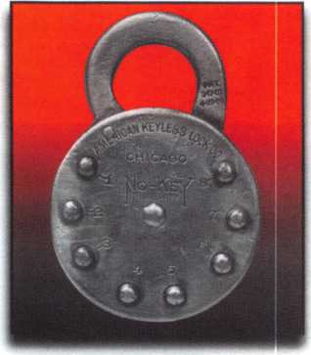

This is the specialty lock issue of Keynotes, and what better way to start out our new lock history column than by exploring the history of the no-key padlock? Thanks are in order, to the following fellow lock collectors (in alphabetical order) for contributing to this article: Vartan Adajian, Charlie Cameron, CML, Lane Clark, Bob Dix, Bob Heilemann, Tom Hennessy, Don Jackson, A1 Ott and Steve Studt.

The No-Key is a favorite among lock collectors, and often finds its way into locksmith shops when the combination is unknown. Six brand name variations from four different cities are known: American (Chicago), Berkmann (Chica­go), Blakesley (probably Denver),

Edwards (Cincinnati), Good News (Min­neapolis) and one unknown variation.

There could be more versions in attics, barns and antique dealers’ cases.

Patents

Two patent dates are stamped on the shackle of all known padlocks: 9-17-07

and 4-27-09. These dates correspond to patent numbers 866,567 and 919,415.

Both were granted to O.J. Blakesley and assigned to the Blakesley Keyless Lock Co. of Denver. The latter patent shows a padlock with combination buttons extending from the edge of the case. Blakesley was also granted patent 992,400 on May 16,1911. This patent shows the lock as we know it, yet this patent date doesn’t appear on any of the locks in common circulation. In any case, the patents suggest that the locks marked “Blakesley” are the earliest, and will prob­ably continue to be the rarest.

Press

Do Not Press UP

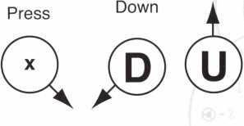

Arrows designate shim position  
as viewed from edge of lock case.

Brand Name Histories

Information about the manufacturers -- or resellers -- is sparse. The only refer­ence found to The American Keyless Lock Co. was in a Plant Purchasing Directory from 1947. Berkmann Mfg. Company’s address was 625 W. Jackson Blvd. in Chicago, as printed on original combination tags. The company name appeared in a Chilton Directory from 1926. Berkmann’s instruction tag did not include combination changing instruc­

tions. Instead, the user was directed to send the lock back to Berkmann Mfg. to have it changed. At this time, no infor­mation is available on on the Good Times Co. of Minneapolis, nor of the Edwards Mfg. Co. of Cincinnati. There is some historical information on the O.M. Edwards Co. of Syracuse, NY, but I don’t believe there is any connection between that lock company and this Edwards.

Value

The American and Edwards versions are the most common. While antique dealers often price these as though they were made of solid gold, the current going price at lock collectors’ shows is around $35, depending on condition. The Blakesley, Berkmann and Good Times versions are considerably rarer, and are more valuable.

Editor's Note: An expanded version of this article — including drawings, dia­grams, original operating instructions and the Curious Curator's very own method for decoding the lock -- is now available in the Member's Only section of the ALOA web site, [www.aloa.org](http://www.aloa.org).

About the Author: AJ. Hoffman, CML is a recog­nized industry authority on interchangeable core and master keying. AJ is currently employed by IR Security & Safety. He authored the Kaba Manual and the Corbin Russwin Cylinder Manual both of which are listed as study references by the ALOA PRP. He served as Co-Chairman of the LIST council and has been an ALOA certified instructor for many years. He is also the Curator of the ALOA Robert Bell Lock Museum.



Keynotes • February 2004



*lose who passed over it on their way to Virginia City and the gold recently discovered there. Fuller also rovided gold-seekers with a place to rest, purchase a meal, and exchange information with other rospectors.*

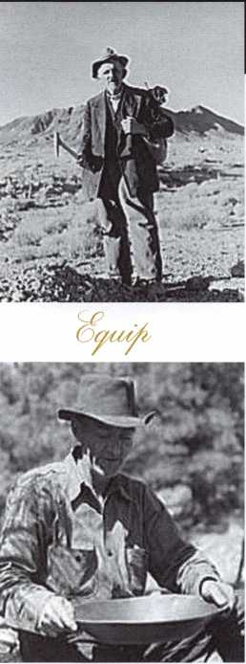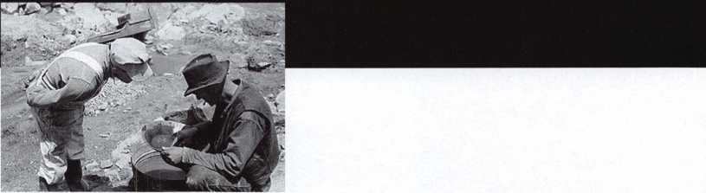

*SSL*

Keeping up with the latest the industry has to offer has never been more impor­tant for safe technicians. Time is of the essence when it comes to education. New developments spring up each year, making top-notch safe classes as good as gold in our ever-changing environment. The only chance to get world-class education and meet with the industry's top safe technicians and suppliers is the SAFETECH Convention and Trade Show. SAFETECH 2004 offers you a chance to explore your profession in ways you never thought possible. Register now to benefit from the future of this exciting industry.



*'WW&t*



*ewnrf cj/' it/ie vuo/t wic/udfoy/*

**SAFETECH 2004**

MARCH 21-27  
JOHN ASCUAGA'S  
NUGGET RESORT  
RENO, NEVADA

**Did you Know...**

**...the Dealers charge an average of $100 per transponder key?**

**...you can get the factory transponder tool for less than the cost of doing one key per month?**

**Say "YES" to $100 phone calls.**

**rau'rjd neyer^onlyouriown... folliFreelfechnical Support**

IBu§2&^a-^°8p Jtt

**YouniKev to Unlocking Ford/Mazda  
Jransponder Profits,**

**CAN VI**

**81201L**

**Use what the Dealers use for complete  
coverage on ALL Ford/Lincoln-Mercury and  
Mazda vehicles equipped with transponder  
keys. The IMGS XL CAN offers complete**

**transponder coverage including CAN protocol**

**and the ability to clear ALL Diagnostic Service Codes.**

**2004 Software Update and CAN Vehic Interface Module now available.**

***MADE***

^aV

***USA***

**HICKOI**

**"I've lost my Taurus keys... can you make me a new set?"**

**How much of your money have you sent to the local Ford Dealer?**

**NGS STAR XL CAN**

**Locksmith 8008LXLC**

**New Generation STAR XL CAI> Transponder Programmei**

**© Waekon/Hickok Inc. 2004 All rights reserved.**

**INCORPORAT**

